**PROJECT-II REPORT**

**On**

**ASSESSMENT PORTAL**

Submitted to Rajasthan Technical University

in partial fulfillment of the requirement for the award of the degree of

**B.TECH.**

**in**

**COMPUTER ENGINEERING**

**Submitted By**

**Pankaj Sharma(PIET15CE070)**

**Sunil Jangid (PIET15CE111)**

**Ravi kumawat (PIET15CE088)**

**Under the Guidance of**

**Mr. Praveen Gupta**

At



**POORNIMA INSTITUTE OF ENGINEERING & TECHNOLOGY, JAIPUR**

**Rajasthan Technical University, KOTA**

**APRIL, 2018**

**CERTIFICATE**

This is to be certified that the project entitled “**Assessment Portal**” has been submitted for the Bachelor of Computer Science and Engineering, Poornima Institute Of Engineering & Technology, Jaipur during the academic year 2018-2019 is a bonafide piece of project work carried out by “ **Pankaj, Ravi & Sunil**” towards the partial fulfillment for the award of the Degree (B.Tech.) under the guidance of “**Mr. Praveen Gupta**” and supervision and no part of thereof has been submitted by them for any degree or diploma.

Project Guide Project Coordinator Mr. Deepak Moud

Mr. Praveen Gupta Prof. (Dr.) Praveen Gupta (H.O.DCSE)

(Assistant Professor) (Professor)

**CANDIDATE’S DECLARATION**

We, **Pankaj Sharma** **(PIET15CE070), Ravi Kumawat(PIET15CE088) & Sunil Kumar Jangid(PIET15CE111)** B.Tech (Semester- VII) of “**Poornima Institute Of Engineering & Technology, Jaipur”**

hereby declare that the Project Report entitled **“Assessment Portal”** is an original work and data provided in the study is authentic to the best of our knowledge.This report has not been submitted to any other Institute for the award of any other degree.

|  |  |  |
| --- | --- | --- |
| **Pankaj sharma** | **Ravi Kumawat** | **sunil kumar jangid** |
| **(PIET15CE070)** | **(PIET15CE088)** | **(PIET15CE111)** |

|  |  |
| --- | --- |
| **Place: JAIPUR** |  |
| **Date:23/10/2018** |  |

**ACKNOWLEDGEMENT**

It is our pleasure to be indebted to various people, who directly or indirectly contributed in the development of this work and who influenced our thinking, behavior and acts during the course of study.

We express our sincere gratitude to ***Dr. O. P. Sharma,*** Director, PIET for providing us an opportunity to undergo this Major Project as the part of the curriculum.

We are thankful to ***Mr. Deepak Moud, HOD, CS*** for his support, cooperation, and motivation provided to us during the training for constant inspiration, presence and blessings.

We are thankful to ***Mr. Praveen Gupta*** for his support, cooperation, and motivation provided to us during the training for constant inspiration, presence and blessings.

We also extend our sincere appreciation to***Prof. (Dr.) Praveen Gupta*** who provided his valuable suggestions and precious time in accomplishing our Project report.

Lastly, we would like to thank the almighty and our parents for their moral support and friends with whom we shared our day-to-day experience and received lots of suggestions that improved our quality of work.

|  |  |  |
| --- | --- | --- |
| **Pankaj sharma** | **Ravi Kumawat** | **sunil kumar jangid** |
| **(PIET15CE070)** | **(PIET15CE088)** | **(PIET15CE111)** |

**TABLE OF CONTENTS**

|  |  |  |
| --- | --- | --- |
| **CHAPTER NO.** | **TOPICS** | **PAGE NO.** |
|  | TITLE PAGE | I |
|  | CERTIFICATE | II |
|  | CANDIDATE’S DECLARATION | III |
|  | ACKNOWLEDGEMENT | IV |
|  | TABLE OF CONTENTS | V |
|  | TABLE OF FIGURE | VI |
|  | ABSTRACT | VII |
| 1 | **INTRODUCTION TO PROJECT** | 1 |
|  |  |  |
|  | Project Aim and Objective  Problem Statement  Background of the Project (Literature Survey)  Software Requirements  Hardware Requirements |  |
| 2 | **PRODUCT BACKLOG** |  |
|  | 1. PRODUCT Backlog 2. Sprint Backlog-1 3. Sprint Backlog-2 4. Sprint Backlog-3 5. Sprint Backlog-4 |  |
|  |  |  |
| 3 | **TECHNOLOGY APPLIED AND PROJECT MANAGEMENT** |  |
|  | Brief Description of All technology Apply in the Project.  Project management  Agile  Relevance to Society  Ethics  Life Long Learning  Project Finance  Environment and Sustainability |  |
|  |  |  |
|  |  |  |
| 4 | **PROJECT IMPLEMENTATION** |  |
|  | Sprint Backlog-1  Sprint Backlog-2  Sprint Backlog-3  Sprint Backlog-4 |  |
|  |  |  |
| 5 | **CONCLUSION** |  |
|  | Results  Conclusion  Future Scope |  |
| 6 | ANNEXURES |  |
|  | References |  |
|  | APPENDIX/ANNEXURES |  |
|  | Research Paper ( if Presented and approved for publication) |  |
|  | CV |  |
|  |  |  |

**LIST OF FIGURES**

|  |  |  |
| --- | --- | --- |
| **S. NO.** | **FIGURE** | **PAGE NO.** |
| 1. |  | 13 |
| 2. |  |  |
| 3. |  |  |
| 4. |  |  |
| 5. |  |  |
| 6. |  |  |
| 7. |  |  |
| 8. |  |  |

**LIST OF TABLES AND DIAGRAM**

**Diagram:**

**Data Flow Diagram (DFD):**

A **data flow diagram** (**DFD**) is a graphical representation of the "flow" of data through an information system, modeling its *process* aspects. A DFD is often used as a preliminary step to create an overview of the

system. DFDs can also be used for the visualization of data processing.

A DFD shows what kind of information will be input to and output from the system, where the data will come from and go to, and where the data will be stored. It does not show information about the timing of process or information about whether processes will operate in sequence or in parallel.

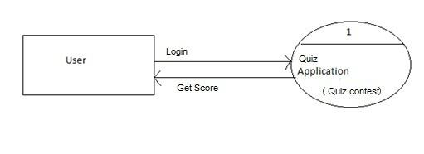

**Use Case Diagram:**

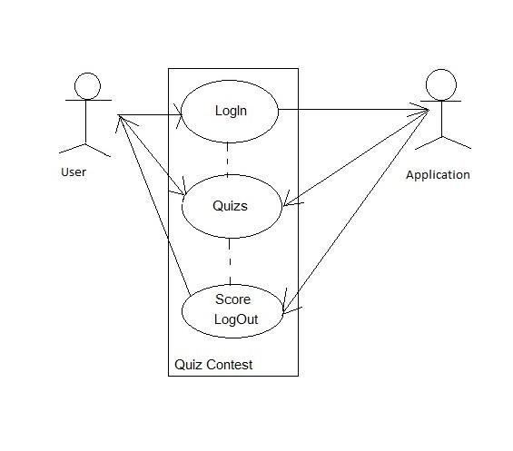

Entity-Relationship Diagram:

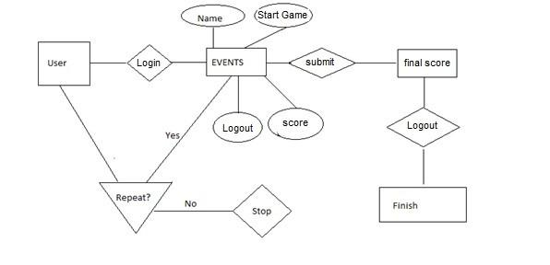

**Table Diagram:**

Design of database table which is named as Events is given below ---

|  |  |
| --- | --- |
|  |  |
| **Attribute Name** | **Attribute type** |
| **Id** | Int |
| **Name** | Text |
| **Info** | Text |
| **Period** | Text |
| **Period_unit** | Text |
| **Start_time** | Text |

**ABSTRACT**

**KEYWORDS:**

Quiz Contest is an android application that has general questions related to current affairs and computer. It has multiple choice questions with time limit and it also calculate scores of each correct answer. It is good for students of every age group it helps in increasing general knowledge about world, Sports and computer etc. Don't need register simply give any user name and password it will saved automatically and you can login again with same user name and password don’t have to worry about the past score. The application helps the user to increase his/her knowledge. Since Smartphone mobiles are being widely used by general population and students, the Quiz Contest application can provide on the Student's mobile.

**Assessment Portal with Following** –

1. Interactive Online / Web based Application

2. Mobile/Android APP

3. There are 2 type of user

● Student (Exam/Result showing after exam)

● Admin (Login,Signup/Upload Question & Answer sheet) (Only available on

website)

4. Key features –

a. Student

i. Name , Registration number, aadhar number

ii. Select sector and exam

iii. Then he can see result after exam

b. Admin Profile

I. Upload Excel Sheet (Question Paper as Well Answer Keys of Question)

II. Manger result and exams

III. Can start new exam can edit marks for question for a particular exam ,

can select minus marking is there or not.

**CHAPTER 1**

**INTRODUCTION TO PROJECT**

( 10 to 15 page)

1. Project Aim and Objective

2. Problem Statement

3. Background of the Project(Literature Survey)

4. Software Requirements

5. Hardware Requirements

**Objective**:

The main objective of “Quiz Contest” is to facilitate a user friendly environment for all users and reduces the manual effort. In past days quiz is conducted manually but in further resolution of the technology we are able to generate the score and pose the queries automatically. The functional requirements include creating users that are going to participate in the quiz, automatic score and report generation and administrative tasks like add, delete, update for admin privilege users. In this application, all the permissions lies with the administrator i.e., specifying the details of the quiz with checking result will show to interviewee or not, addition of question and answers marks for each question, Set timer for each quiz and generate report with score for each quiz.

**Problem Definition**:

Quiz Contest is a application developed to conduct an quiz based on time constraints. Quiz Contest system is accessed by entering the user name and password which is added to the database. Before start of the quiz, the rules and regulations are displayed that includes description of the time limit, number of questions to be answered and scoring methods. Quiz is started by displaying one question with four options each based on computer and general knowledge. if the answer is correct,

7 score is incremented by four and no negative marks for wrong answers. If the time exceeds 20secs next question will come automatically after giving few limited question's answer quiz application will finally direct you to the score page. Final score will be displayed and updated in the database with username.

**Basic Concepts & Tools**:

**Introduction to Java:**

Java is a programming language created by James Gosling from Sun Microsystems (Sun) in 1991. The first publicly available version of Java (Java 1.0) was released in 1995. Sun Microsystems was acquired by the Oracle Corporation in 2010. Over time new enhanced versions of Java have been released. The current version of Java is Java 1.7 which is also known as Java 7. From the Java programming language the Java platform evolved. The Java platform allows software developers to write

9 program code in other languages than the Java programming language and still runs on the Java virtual machine. The Java platform is usually associated with the Java virtual machine and the Java core libraries.

**Java Virtual machine**:

The Java virtual machine (JVM) is a software implementation of a computer that executes programs like a real machine. The Java virtual machine is written specifically for a specific operating system, e.g. for Linux a special implementation is required as well as for Windows.

**Java Runtime Environment vs. Java Development Kit:**

A Java distribution comes typically in two flavours, the Java Runtime Environment (JRE) and the Java Development Kit (JDK).The Java runtime environment (JRE) consists of the JVM and the Java class libraries and contains the necessary functionality to start Java programs. The JDK contains in addition the development tools necessary to create Java programs. The JDK consists therefore of a Java

compiler, the Java virtual machine, and the Java class libraries.

**Characteristics of Java:**

The target of Java is to write a program once and then run this program on multiple operating systems. Java has the following properties: Platform independent: Java programs use the Java virtual machine as abstraction and do not access the operating system directly. This makes Java programs highly portable. A Java program (which is standard complaint and follows certain rules) can run unmodified on all supported platforms, e.g. Windows or Linux. Object-orientated programming language: Except the primitive data types, all elements in Java are objects.

**Interpreted and compiled language**:

Java source code is transferred into the byte code format which does not depend on the target platform. These byte code instructions will be interpreted by the Java Virtual machine (JVM). The JVM contains a so called Hotspot-Compiler which translates performance critical byte code instructions into native code instructions.

**Automatic memory management:**

Java manages the memory allocation and de-allocation for creating new objects. The program does not have direct access to the memory. The so-called garbage collector deletes automatically objects to which no active pointer exists.

**Android:**

Android is a software platform and operating system for mobile devices. Android is available as open source. It allows developers to write managed code in the Java language, controlling the device via Google-developed Java libraries. Android SDK was released by Open Handset Alliance in the month of November of the year 2007. Android was actually developed using the kernel of Linux 2.6 and the highlighting features of Android include the following: • No fees for licensing, distribution and release approval • GSM, 3G EDGE networks for telephony • IPC message passing

• Background processes and applications

• Complete multimedia hardware control

• API’s for location based services such as GPS.

➢ Components of Android The basic components of an Android application include Activity, Broadcast Receiver, Service, and Content Provider. Each of the above, which when used for any application, has to be declared in the AndroidManifest.xml. The user interface of the component is determined by the Views. For the communication among these basic components we use Intents and Intent filters which play crucial role during app development.

**Android Components**

**Activity**:

An Activity is, fundamentally, an object that has a lifecycle. An Activity is a chunk of code that does some work, as necessary. The work can include displaying a UI to the user, though it doesn't have to as some Activities never display UIs. Typically,

we designate one of our application's Activities as the entry point to our application. Broadcast Receiver Broadcast Receiver is yet another type of component that can receive and respond to any of the broadcast announcements.

**Service**:

A Service is a body of code that runs in the background. It can run in its own process, or in the context of another application's process, depending on its needs. Other components "bind" to a Service and invoke methods on it via remote procedure calls. An example of a Service is a media player; even when the user quits the media selection UI, she probably still intends for her music to keep playing. A Service keeps the music going even when the UI has completed.

**Content Provider**:

Content Provider is a data storehouse that provides access to data on the device; the classic example is the Content Provider that is used to access the user's list of contacts. Our application can access data that other applications have exposed via a Content Provider, and we can also define our own Content Providers to expose data of our own.

**Software Requirements:**

1. **Operating System**: Android
2. **Toolkit**: Software Development Toolkit(SDK)
3. **Platform**  : Java and Android
4. **Database:** SQLite

**Hardware Requirements:**

1. **minimum version** (API 19)
2. **Android phone** (Having Version Above or 2.3)

**CHAPTER 2**

**PRODUCT BACKLOG**

1. **PRODUCT Backlog**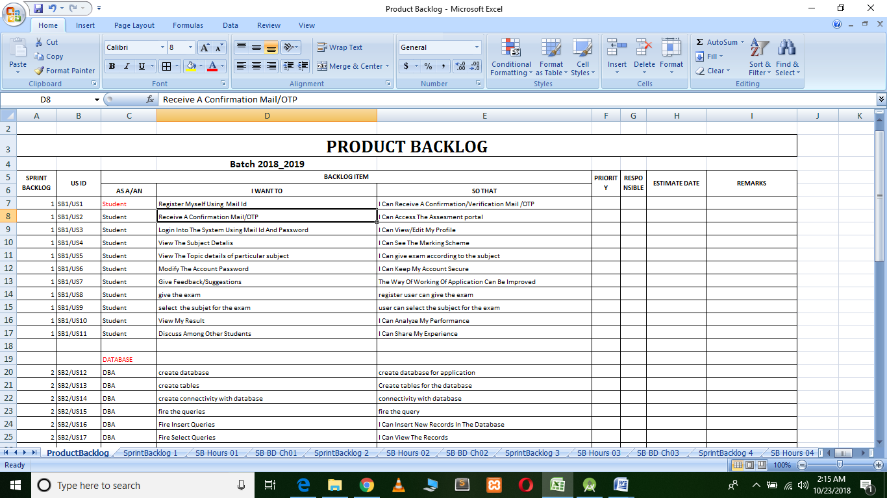

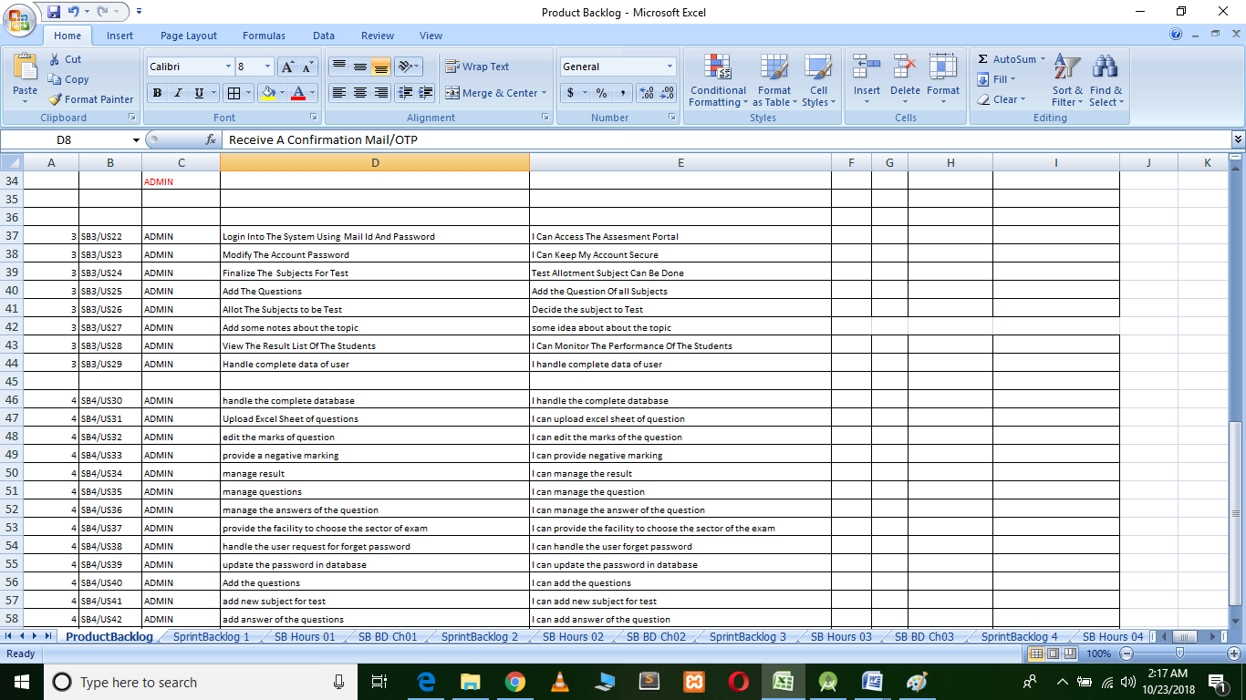

1. **Sprint Backlog-1**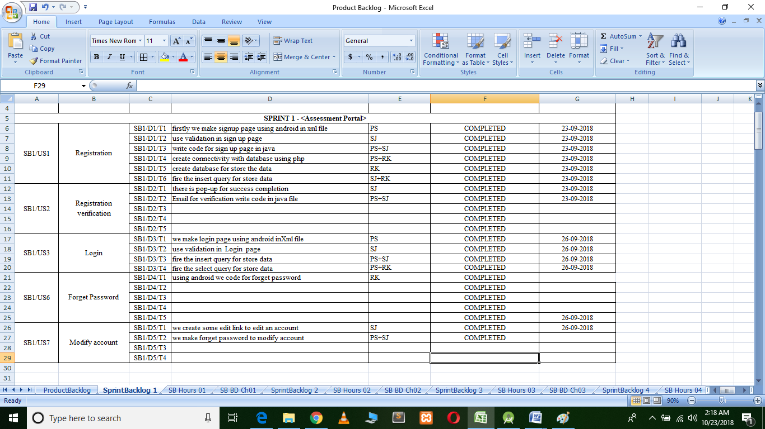

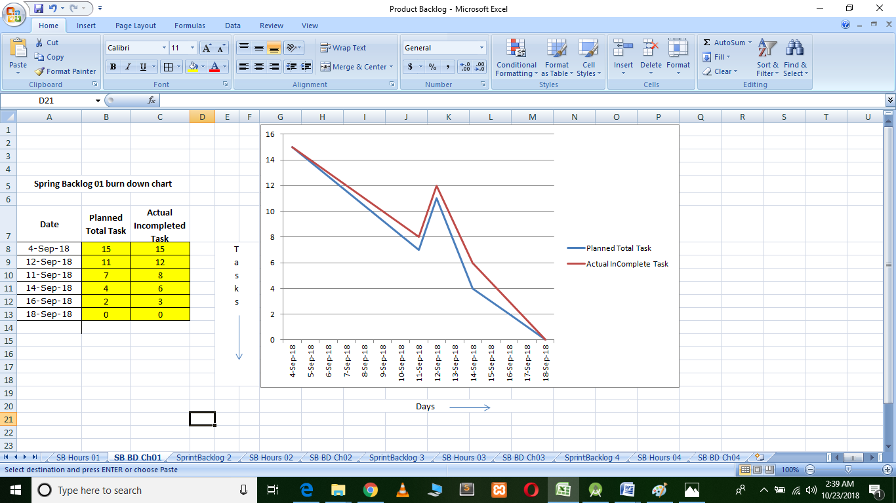

3. **Sprint Backlog-2**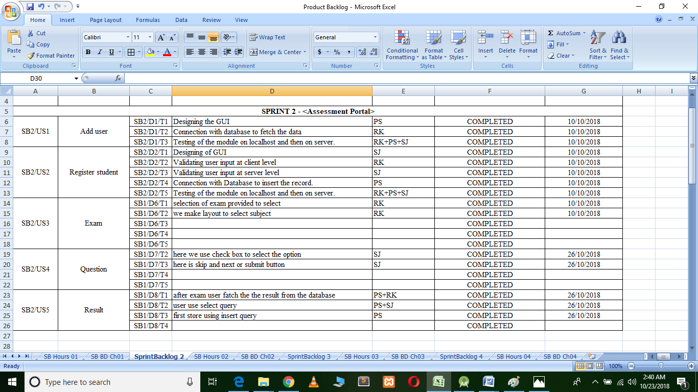 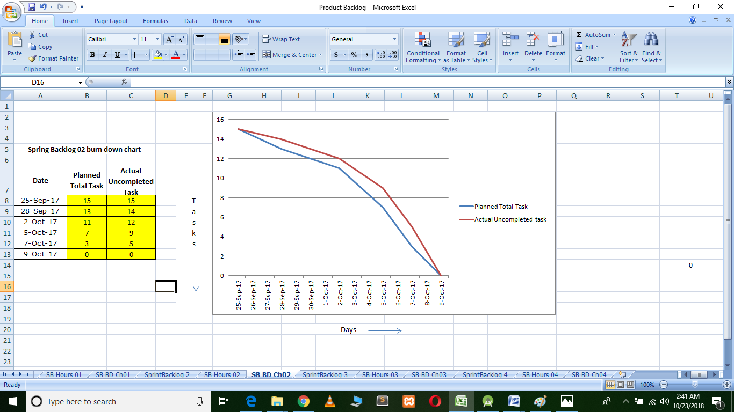4. **Sprint Backlog-3**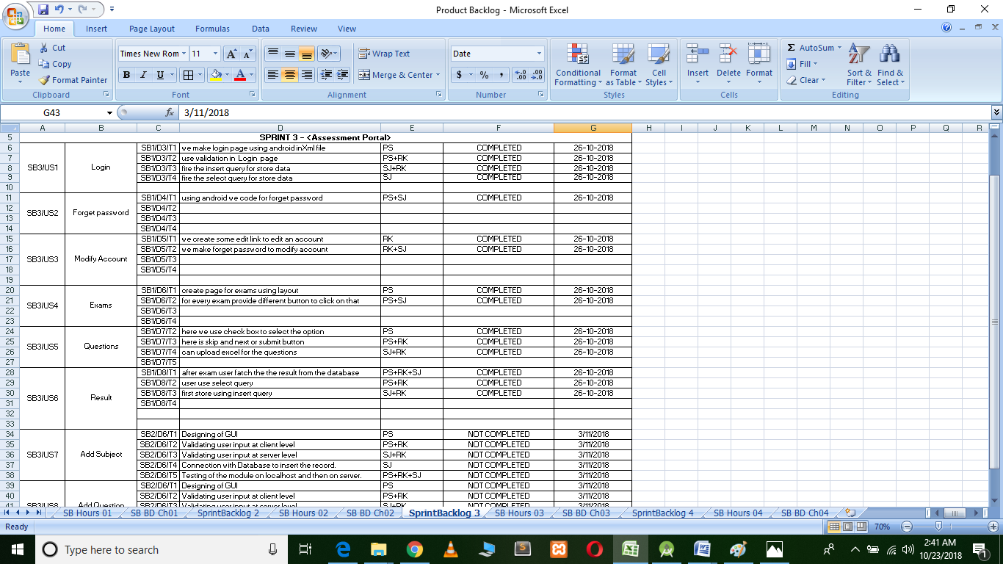 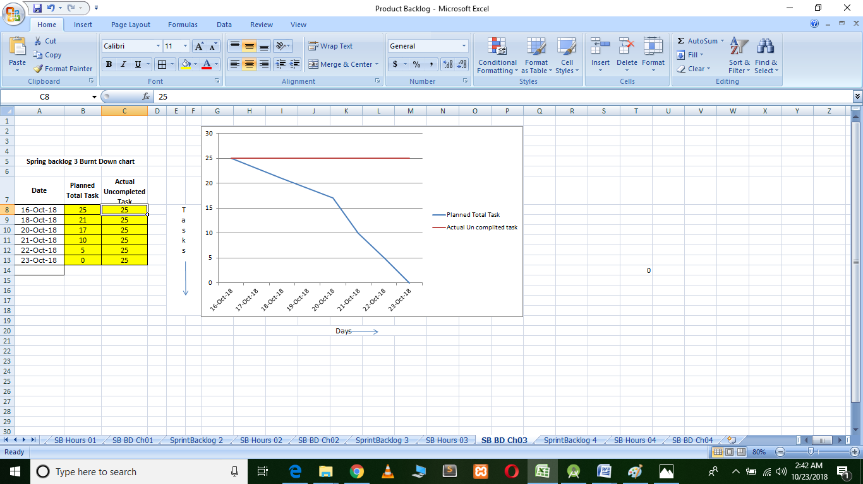

**Sprint Backlog-4**

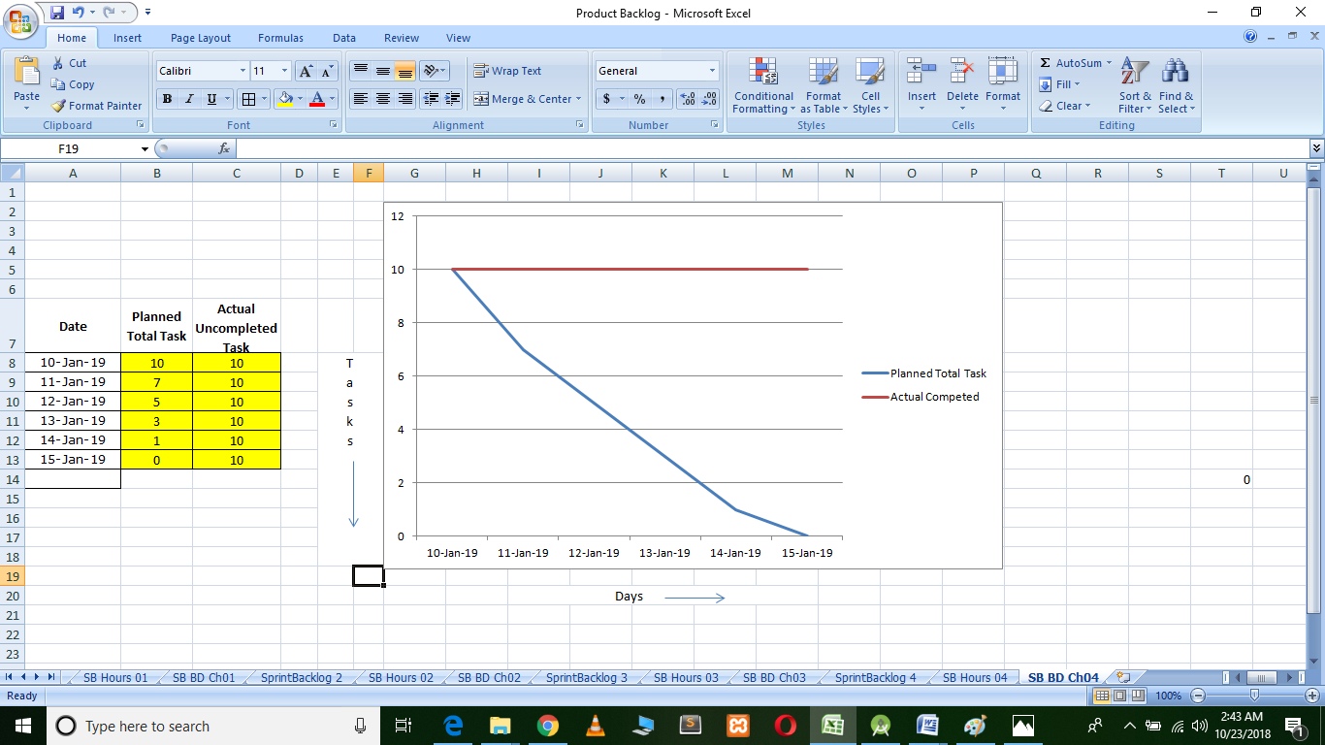

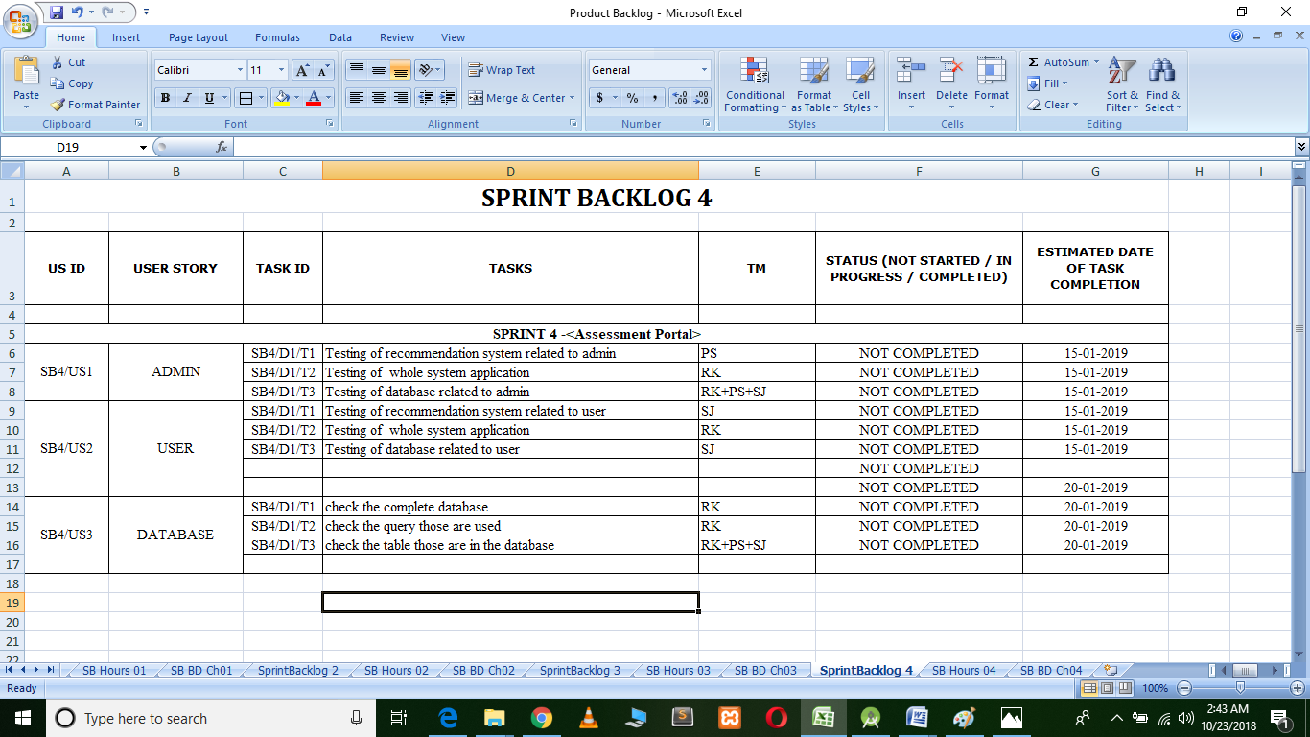

**CHAPTER 3**

**TECHNOLOGY APPLIED AND PROJECT MANAGEMENT**

( 10 to 15 page)

Brief Description of All technologiesAppled in the Project.

**Project management :**

Project management is the application of processes, methods, knowledge, skills and experience to achieve the project objectives. General. A project is a unique, transient endeavor, undertaken to achieve planned objectives, which could be defined in terms of outputs, outcomes or benefits.

Project management is the practise of initiating, planning, executing, controlling, and closing the [work](https://en.wikipedia.org/wiki/Work_(project_management)) of a [team](https://en.wikipedia.org/wiki/Project_team) to achieve specific goals and meet specific success criteria at the specified time. A [project](https://en.wikipedia.org/wiki/Project) is a temporary endeavor designed to produce a unique product, service or result with a defined beginning and end undertaken to meet unique goals and objectives, typically to bring about beneficial change or added value. The temporary nature of projects stands in contrast with [business as usual](https://en.wikipedia.org/wiki/Business_operations), which are repetitive, permanent, or semi-permanent functional activities to produce products or services. In practice, the [management](https://en.wikipedia.org/wiki/Management) of such distinct production approaches requires the development of distinct technical skills and management strategies.

**Software project management**

Software project management is the art and science of planning and leading software projects. It is a sub-discipline of [project management](https://en.wikipedia.org/wiki/Project_management) in which [software](https://en.wikipedia.org/wiki/Software) projects are planned, implemented, monitored and controlled.

The job pattern of an IT company engaged in software development can be seen split in two parts:

* Software Creation
* Software Project Management

A project is well-defined task, which is a collection of several operations done in order to achieve a goal (for example, software development and delivery). A Project can be characterized as:

* Every project may have a unique and distinct goal.
* Project is not routine activity or day-to-day operations.
* Project comes with a start time and end time.
* Project ends when its goal is achieved hence it is a temporary phase in the lifetime of an organization.
* Project needs adequate resources in terms of time, manpower, finance, material and knowledge-bank.

**Software Project**

A Software Project is the complete procedure of software development from requirement gathering to testing and maintenance, carried out according to the execution methodologies, in a specified period of time to achieve intended software product.

**Need of software project management**

Software is said to be an intangible product. Software development is a kind of all new stream in world business and there’s very little experience in building software products. Most software products are tailor made to fit client’s requirements. The most important is that the underlying technology changes and advances so frequently and rapidly that experience of one product may not be applied to the other one. All such business and environmental constraints bring risk in software development hence it is essential to manage software projects efficiently.

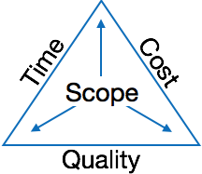

The image above shows triple constraints for software projects. It is an essential part of software organization to deliver quality product, keeping the cost within client’s budget constrain and deliver the project as per scheduled. There are several factors, both internal and external, which may impact this triple constrain triangle. Any of three factor can severely impact the other two.

Therefore, software project management is essential to incorporate user requirements along with budget and time constraints.

**Software Project Manager**

A software project manager is a person who undertakes the responsibility of executing the software project. Software project manager is thoroughly aware of all the phases of SDLC that the software would go through. Project manager may never directly involve in producing the end product but he controls and manages the activities involved in production.

A project manager closely monitors the development process, prepares and executes various plans, arranges necessary and adequate resources, maintains communication among all team members in order to address issues of cost, budget, resources, time, quality and customer satisfaction.

Let us see few responsibilities that a project manager shoulders -

**Managing People**

* Act as project leader
* Liaison with stakeholders
* Managing human resources
* Setting up reporting hierarchy etc.

**Managing Project**

* Defining and setting up project scope
* Managing project management activities
* Monitoring progress and performance
* Risk analysis at every phase
* Take necessary step to avoid or come out of problems
* Act as project spokesperson

**Software Management Activities**

Software project management comprises of a number of activities, which contains planning of project, deciding scope of software product, estimation of cost in various terms, scheduling of tasks and events, and resource management. Project management activities may include:

* **Project Planning**
* **Scope Management**
* **Project Estimation**

**Project Planning**

Software project planning is task, which is performed before the production of software actually starts. It is there for the software production but involves no concrete activity that has any direction connection with software production; rather it is a set of multiple processes, which facilitates software production. Project planning may include the following:

**Scope Management**

It defines the scope of project; this includes all the activities, process need to be done in order to make a deliverable software product. Scope management is essential because it creates boundaries of the project by clearly defining what would be done in the project and what would not be done. This makes project to contain limited and quantifiable tasks, which can easily be documented and in turn avoids cost and time overrun.

During Project Scope management, it is necessary to -

* Define the scope
* Decide its verification and control
* Divide the project into various smaller parts for ease of management.
* Verify the scope
* Control the scope by incorporating changes to the scope

**Project Estimation**

For an effective management accurate estimation of various measures is a must. With correct estimation managers can manage and control the project more efficiently and effectively.

Project estimation may involve the following:

* **Software size estimation**

Software size may be estimated either in terms of KLOC (Kilo Line of Code) or by calculating number of function points in the software. Lines of code depend upon coding practices and Function points vary according to the user or software requirement.

* **Effort estimation**

The managers estimate efforts in terms of personnel requirement and man-hour required to produce the software. For effort estimation software size should be known. This can either be derived by managers’ experience, organization’s historical data or software size can be converted into efforts by using some standard formulae.

* **Time estimation**

Once size and efforts are estimated, the time required to produce the software can be estimated. An effort required is segregated into sub categories as per the requirement specifications and interdependency of various components of software. Software tasks are divided into smaller tasks, activities or events by Work Breakthrough Structure (WBS). The tasks are scheduled on day-to-day basis or in calendar months.

The sum of time required to complete all tasks in hours or days is the total time invested to complete the project.

* **Cost estimation**

This might be considered as the most difficult of all because it depends on more elements than any of the previous ones. For estimating project cost, it is required to consider -

* + Size of software
  + Software quality
  + Hardware
  + Additional software or tools, licenses etc.
  + Skilled personnel with task-specific skills
  + Travel involved
  + Communication
  + Training and support

**Project Estimation Techniques**

We discussed various parameters involving project estimation such as size, effort, time and cost.Project manager can estimate the listed factors using two broadly recognized techniques

**Decomposition Technique**

This technique assumes the software as a product of various compositions.

There are two main models -

* **Line of Code** Estimation is done on behalf of number of line of codes in the software product.
* **Function Points** Estimation is done on behalf of number of function points in the software product.

**Empirical Estimation Technique**

This technique uses empirically derived formulae to make estimation.These formulae are based on LOC or FPs.

* **Putnam Model**

This model is made by Lawrence H. Putnam, which is based on Norden’s frequency distribution (Rayleigh curve). Putnam model maps time and efforts required with software size.

* **COCOMO**

COCOMO stands for COnstructiveCOstMOdel, developed by Barry W. Boehm. It divides the software product into three categories of software: organic, semi-detached and embedded.

**Project Scheduling**

Project Scheduling in a project refers to roadmap of all activities to be done with specified order and within time slot allotted to each activity. Project managers tend to define various tasks, and project milestones and they arrange them keeping various factors in mind. They look for tasks lie in critical path in the schedule, which are necessary to complete in specific manner and strictly within the time allocated. Arrangement of tasks which lies out of critical path are less likely to impact over all schedule of the project.

For scheduling a project, it is necessary to -

* Break down the project tasks into smaller, manageable form
* Find out various tasks and correlate them
* Estimate time frame required for each task
* Divide time into work-units
* Assign adequate number of work-units for each task
* Calculate total time required for the project from start to finish

**Resource management**

All elements used to develop a software product may be assumed as resource for that project. This may include human resource, productive tools and software libraries.

The resources are available in limited quantity and stay in the organization as a pool of assets. The shortage of resources hampers the development of project and it can lag behind the schedule. Allocating extra resources increases development cost in the end. It is therefore necessary to estimate and allocate adequate resources for the project.

Resource management includes -

* Defining proper organization project by creating a project team and allocating responsibilities to each team member
* Determining resources required at a particular stage and their availability
* Manage Resources by generating resource request when they are required and de-allocating them when they are no more needed.

**Project Risk Management**

Risk management involves all activities pertaining to identification, analysing and making provision for predictable and non-predictable risks in the project. Risk may include the following:

* Experienced staff leaving the project and new staff coming in.
* Change in organizational management.
* Requirement change or misinterpreting requirement.
* Under-estimation of required time and resources.
* Technological changes, environmental changes, business competition.

**Risk Management Process**

There are following activities involved in risk management process:

* **Identification -** Make note of all possible risks, which may occur in the project.
* **Categorize -** Categorize known risks into high, medium and low risk intensity as per their possible impact on the project.
* **Manage -** Analyze the probability of occurrence of risks at various phases. Make plan to avoid or face risks. Attempt to minimize their side-effects.
* **Monitor -** Closely monitor the potential risks and their early symptoms. Also monitor the effects of steps taken to mitigate or avoid them.

**Project Execution & Monitoring**

In this phase, the tasks described in project plans are executed according to their schedules.

Execution needs monitoring in order to check whether everything is going according to the plan. Monitoring is observing to check the probability of risk and taking measures to address the risk or report the status of various tasks.

These measures include -

* **Activity Monitoring -** All activities scheduled within some task can be monitored on day-to-day basis. When all activities in a task are completed, it is considered as complete.
* **Status Reports -** The reports contain status of activities and tasks completed within a given time frame, generally a week. Status can be marked as finished, pending or work-in-progress etc.
* **Milestones Checklist -** Every project is divided into multiple phases where major tasks are performed (milestones) based on the phases of SDLC. This milestone checklist is prepared once every few weeks and reports the status of milestones.

**Project Communication Management**

Effective communication plays vital role in the success of a project. It bridges gaps between client and the organization, among the team members as well as other stake holders in the project such as hardware suppliers.

Communication can be oral or written. Communication management process may have the following steps:

* **Planning** - This step includes the identifications of all the stakeholders in the project and the mode of communication among them. It also considers if any additional communication facilities are required.
* **Sharing** - After determining various aspects of planning, manager focuses on sharing correct information with the correct person on correct time. This keeps every one involved the project up to date with project progress and its status.
* **Feedback** - Project managers use various measures and feedback mechanism and create status and performance reports. This mechanism ensures that input from various stakeholders is coming to the project manager as their feedback.
* **Closure** - At the end of each major event, end of a phase of SDLC or end of the project itself, administrative closure is formally announced to update every stakeholder by sending email, by distributing a hardcopy of document or by other mean of effective communication.

After closure, the team moves to next phase or project.

**Configuration Management**

Configuration management is a process of tracking and controlling the changes in software in terms of the requirements, design, functions and development of the product.

IEEE defines it as “the process of identifying and defining the items in the system, controlling the change of these items throughout their life cycle, recording and reporting the status of items and change requests, and verifying the completeness and correctness of items”.

Generally, once the SRS is finalized there is less chance of requirement of changes from user. If they occur, the changes are addressed only with prior approval of higher management, as there is a possibility of cost and time overrun.

**Project management Tools:**

Project management required tools to manage the work , time and resources. At present many of the software are available for project management. Some of the popular software tools are as follows.

### 01. [Trello](http://send.getapp.com/aff_c?offer_id=677&aff_id=1371)

Trello is an project management tool, instead this app is a free visual way to to glance at the entire project with a single view. With Trello you can organise cards, these cards can be your thoughts, conversations and to-do lists and be placed on a board for everyone to collaborate on.

### 02. [Basecamp](http://send.getapp.com/aff_c?offer_id=637&aff_id=1371)

Basecamp is the granddaddy of project management apps. Basecamp is considered the leading project management tool around. It boost a simple and easy to use interface to collaborate with your team and client. It allows you to create multiple projects and setup discussions, write to-do lists, manage files, create and share documents, and organise dates for scheduling.

### 03. [Teamwork Projects](http://send.getapp.com/aff_c?offer_id=947&aff_id=1371)

Teamwork Projects is the ultimate productivity tool to manage projects with your team. Teamwork allows you to keep all your projects, tasks and files all in one place and easily collaborate with a team. Teamwork helps you to visualise the entire project through a marked calendar and gantt chart and setup reporting. Teamwork supports file management with Google Drive, Box.com and Dropbox. As well as integration with leading apps such as third party accounting software and customer support apps.

### 04. [Resource Guru](https://resourceguruapp.com/)

Billed as the "simple way to schedule people, equipment and other resources", Resource Guru is a streamlined resource scheduling and leave management tool that’s designed to keep your projects on track. You can plan your team's workloads, receive daily booking reminders, report on KPIs, and more. Apple, Saatchi & Saatchi and Deloitte are among some of the cloud-based team calendar’s heavyweight customers.

### 05. [ActiveCollab](http://send.getapp.com/aff_c?offer_id=949&aff_id=1371)

ActiveCollab recently released its new version 5.0. The new revamped app is now more powerful and focused project management tool. It offers team collaborating features, task management, time tracking and importing expenses. One of the biggest asset of ActiveCollab is it offers invoicing features. You are able to track payments and expenses and have invoices paid directly within ActiveCollab with PayPal, and other credit card payments.

### 06. [Zoho Projects](http://send.appdoubler.com/aff_c?offer_id=101&aff_id=1371)

Zoho offers a wide range of business software including Projects. Zoho Projects is an proficient tool to project plan and project coordinator from start to finish. It boost all the features you need for project management with some advance features including reporting, integration with Google Apps and Dropbox, bug tracking, setup Wiki Pages to build a repository of information, forums and more.

### 07. [Jira](http://send.getapp.com/aff_c?offer_id=281&aff_id=1371)

Jira is specifically targeted for software development teams. Jira offers abilities to raise issues and bugs. Jira makes it real easy to track bugs and see which issues are still outstanding and how much time was spent on each task. Jira offer other products including Confluence a document collaboration tool, and HipChat a team chat and video and file sharing platform and other products.

### 08. [Asana](http://send.getapp.com/aff_c?offer_id=587&aff_id=1371)

Asana is the easiest way for teams to track their work so everyone knows who's doing what, by when. With tasks, projects, conversations and dashboards, Asana keeps your work organized, and teammates accountable so you can move work forward faster. Asana also lets you keep track of your work wherever you are with mobile apps for both iOS and Android.

### 09. [Podio](http://send.getapp.com/aff_c?offer_id=951&aff_id=1371)

Podio is a ever growing tool to organise and communication tool for any business. Podio allows you to personalise this platform to fit your business needs. Besides being able to communicate with a team, setup task management, use as a file storage system, like a traditional project management app, Podio can be an internal intranet for all your colleagues and departments to interact.

### 10. [Freedcamp](https://freedcamp.com/)

Whatever your project may be, either setting up an event, a web project or organising a wedding, Freedcamp helps you organise and plan effectively. Freedcamp has an organised dashboard to view the entire project at a glance. You can easily setup tasks, use sticky notes to visually setup tasks and organise them into the calendar. Freedcamp provides advance add-ons for high level business use including CRM, invoicing, issue tracking and setting up wiki pages.

### 11. [Wrike](http://send.getapp.com/aff_c?offer_id=239&aff_id=1371)

Wrike is advance application to help you work smarter. By making sure you are always staying on track and ensure you have the adequate resources to finish on time and on budget.Setting up tasks, engage your team and integrate with your business tools including Google Apps, Microsoft Excel, Dropbox and many more is so easy with Wrike.

**PO and Their Relevance to project**

**PO1: Engineering knowledge:**Apply the knowledge of mathematics, science, engineering fundamentals and an engineering specialization to the solution of complex engineering problems.

In this project creation process engineering knowledge of the software engineering and Electronics engineering have been applied. we have used software engineering , HTML,xml, java , android , java script , php , j2ee, data base , oracle , my sql , mango and other programming language and database to the project. We have applied all above engineering subjects in our projects.

**PO2: Problem analysis:**Identify, formulate, review research literature, and analyze complex engineering problems reaching substantiated conclusions using first principles of mathematics, natural sciences, and engineering sciences.

In our projects we have identified an problem , once verified by the client we have worked to identify the solution using all of our theoretical and practical knowledge.

**PO3: Design/development of solutions:** Design solutions for complex engineering problems and design system components or processes that meet the specified needs with appropriate consideration for the public health and safety, and the cultural, societal, and environmental considerations.

**PO4: Conduct investigations of complex problems:** Use research-based knowledge and research methods including design of experiments, analysis and interpretation of data, and synthesis of the information to provide valid conclusions.

**PO5: Modern tool usage:**Create, select, and apply appropriate techniques, resources, and modern engineering and IT tools including prediction and modeling to complex engineering activities with an understanding of the limitations.

In the project development we have applied Integrated Development Environment IDE for the rapid development of the code, used web server for the software development.

**PO6: The engineer and society**: Apply reasoning informed by the contextual knowledge to assess societal, health, safety, legal and cultural issues and the consequent responsibilities relevant to the professional engineering practice.

In 1961 , the Conference of Engineering Societies of Western Europe and the United States of America defined "professional engineer" as follows.

A professional engineer is competent by virtue of his/her fundamental education and training to apply the scientific method and outlook to the analysis and solution of engineering problems. He/she is able to assume personal responsibility for the development and application of engineering science and knowledge, notably in research, design, construction, manufacturing, superintending, managing and in the education of the engineer. His/her work is predominantly intellectual and varied and not of a routine mental or physical character. It requires the exercise of original thought and judgement and the ability to supervise the technical and administrative work of others. His/her education will have been such as to make him/her capable of closely and continuously following progress in his/her branch of engineering science by consulting newly published works on a worldwide basis, assimilating such information and applying it independently. He/she is thus placed in a position to make contributions to the development of engineering science or its applications. His/her education and training will have been such that he/she will have acquired a broad and general appreciation of the engineering sciences as well as thorough insight into the special features of his/her own branch. In due time he/she will be able to give authoritative technical advice and to assume responsibility for the direction of important tasks in his/her branch.

**PO7: Environment and sustainability:** Understand the impact of the professional engineering solutions in and environmental contexts, and demonstrate the knowledge of, and need for sustainable development.

Sustainability is the ability to continue a defined behavior indefinitely. Sometimes environmental, social and economic are termed to be the three pillars of sustainability.

**PO8: Ethics**: Apply ethical principles and commit to professional ethics and responsibilities and norms of the engineering practice

The ethics of engineers and the fundamental principles for Engineers are as follows.

Engineers uphold and advance the integrity, honor and dignity of the engineering profession by:

I. using their knowledge and skill for the enhancement of human welfare;

II.being honest and impartial, and servicing with fidelity the public, their employers and clients;

III. Striving to increase the competence and prestige of the engineering profession; and

IV. Supporting the professional and technical societies of their disciplines.   
  
  
**PO9. Individual and team work**: Function effectively as an individual and as a member or leader in diverse teams, and in multidisciplinary settings.  
  
  
To work successful in team a team member must have following capabilities.

**1. The Ability to Listen**

it is important to listen to one another's ideas. Too often in a business setting, you have a group of people simply waiting for their turn to speak, not paying one iota of attention to the persons on their left or right. So it is a good teamwork skill to have the ability to listen

**2. Check Your Ego**

This isn't saying abandon your ego all together, because that isn't healthy. But leaving your ego at the door temporarily is a very important team work skill. The reason this is so essential is because there is always someone better than you at something, no matter how brilliant you are.

**3. Critique**

By critique, I mean constructive criticism. Be able to give others constructive criticism and be able to listen to others critique your ideas and work. There shouldn't be any offense taken to constructive criticism. You all want to succeed, and this is a vital step in doing so.

**4. Delegation**

The mentality must be applied to teamwork. Delegate roles to those who do them best.

**5. Show Respect**

If you and another person happen to be paired up and can't stand each other, you can still put that aside for a couple of hours, treat each other civilly, and complete the tasks at hand. You may even overcome the dislike toward one another.

**6. Be Helpful**

This is simple.If one of your teammates does not understand an idea, discussion, or task that is being completed, take the necessary time to explain it to them and work with them. There are no weak links when everyone helps one another. Some take longer to learn than others, but that doesn't mean that they are of less intelligence. If in a meeting someone asks a question because they don't understand, don't frown at them. Just answer the questions patiently and concisely.

**7. Question One Another**

If someone brings up a topic of discussion and a solution to this topic, question them. Respectfully question, don't badger. Rather, ask them how it will work, why it will work over the long-run, and how everyone else can implement the idea.

**8. Participation**

Have the entire team encourage shy people to engage in the topics of discussion. Don't demand it, but make them realize that you really want to hear their ideas.

**9. Rational Debate**

Bad ideas are bad for teams. Spirited, friendly, rational debate is where facts come forward, ideas are born, and quality rises to the top.

**10. Set The Right Environment**

Try to make the space in which your team is assembled as comfortable, relaxing, and inviting as possible. You do not want your team to be tense and with frayed nerves.

**PO 10: Communication:**Communicate effectively on complex engineering activities with the engineering community and with society at large, such as, being able to comprehend and write effective reports and design documentation, make effective presentations, and give and receive clear instructions.

**PO11: Project management and finance:**Demonstrate knowledge and understanding of the engineering management principles and apply these to one’s own work, as a member and leader in a team, to manage projects and in multidisciplinary environments.

Project management is the application of processes, methods, knowledge, skills and experience to achieve the project objectives. In general project is a unique, transient endeavour, undertaken to achieve planned objectives, which could be defined in terms of outputs, outcomes or benefits.

**PO12: Life-long learning**: Recognize the need for and have the preparation and ability to engage in independent and lifelong learning in the broadest context of technological change.

Life Long Learning means is the provision or use of both formal and informal learning opportunities throughout people's lives in order to foster the continuous development and improvement of the knowledge and skills needed for employment and personal fulfillment

**CHAPTER 4**

**PROJECT IMPLEMENTATION**

( Each Spring Backlog of 13-17 Pages total Chapter Size 50-70 pages)

1. Sprint Backlog-1  
     
   **Splash Screen: splash.java**

**package** com.example.hp.quiz;  
  
**import** android.content.Intent;  
**import** android.graphics.Typeface;  
**import** android.os.Bundle;  
**import** android.support.v7.app.AppCompatActivity;  
**import** android.widget.Button;  
  
**public class** SplashSceen **extends** AppCompatActivity {  
Button **a**,**b**,**c**,**d**;  
 @Override  
 **protected void** onCreate(Bundle savedInstanceState) {  
 **super**.onCreate(savedInstanceState);  
 setContentView(R.layout.***activity_splash_sceen***);  
 **a**=(Button)findViewById(R.id.***text1***);  
 **b**=(Button)findViewById(R.id.***text2***);  
 **c**=(Button)findViewById(R.id.***text3***);  
 **d**=(Button)findViewById(R.id.***text4***);  
 Typeface tf = Typeface.*createFromAsset*(getApplicationContext().getAssets(),**"fonts/yash.ttf"**);  
 **a**.setTypeface(tf);  
 **b**.setTypeface(tf);  
 **c**.setTypeface(tf);  
 **d**.setTypeface(tf);  
 Thread th=**new** Thread()  
 {  
 @Override  
 **public void** run() {  
 **super**.run();  
 **try** {  
 *sleep*(2000);  
 }**catch**(Exception e){}  
 Intent intent=**new** Intent(SplashSceen.**this**,MainActivity.**class**);  
 startActivity(intent);  
 finish();  
 }  
  
  
 };  
 th.start();  
 }  
}

**splash.xml**

*?***xml version="1.0" encoding="utf-8"***?>*<**RelativeLayout xmlns:android="http://schemas.android.com/apk/res/android"  
 xmlns:tools="http://schemas.android.com/tools"  
 android:layout_width="match_parent"  
 android:layout_height="match_parent"  
 android:paddingBottom="@dimen/activity_vertical_margin"  
 android:paddingLeft="@dimen/activity_horizontal_margin"  
 android:paddingRight="@dimen/activity_horizontal_margin"  
 android:paddingTop="@dimen/activity_vertical_margin"  
 tools:context="com.example.hp.quiz.SplashSceen"  
 android:background="@drawable/blur2"**>  
  
 <**ImageButton  
 android:layout_marginTop="30dp"  
 android:layout_width="match_parent"  
 android:layout_height="wrap_content"  
 android:src="@drawable/brain"  
 android:background="#00FFFFFF"** />  
 <**LinearLayout  
 android:layout_width="match_parent"  
 android:layout_height="wrap_content"  
 android:layout_marginTop="200dp"  
 android:orientation="horizontal"  
 android:gravity="center"  
 android:weightSum="1"**>  
  
 <**Button  
 android:id="@+id/text1"  
 android:layout_width="120dp"  
 android:layout_height="120dp"  
 android:text="Q"  
 android:textAlignment="center"  
 android:textStyle="bold"  
 android:textSize="40dp"  
 android:textColor="@android:color/white"  
 android:background="@drawable/shape4"** />  
 <**Button  
 android:id="@+id/text2"  
 android:layout_width="120dp"  
 android:layout_height="120dp"  
 android:text="U"  
 android:textAlignment="center"  
 android:textStyle="bold"  
 android:textSize="40dp"  
 android:textColor="@android:color/white"  
 android:background="@drawable/shape3"** />  
 </**LinearLayout**>  
  
 <**LinearLayout  
 android:layout_width="match_parent"  
 android:layout_height="wrap_content"  
 android:layout_marginTop="320dp"  
 android:orientation="horizontal"  
 android:gravity="center"  
 android:weightSum="1"**>  
  
 <**Button  
 android:id="@+id/text3"  
 android:layout_width="120dp"  
 android:layout_height="120dp"  
 android:text="I"  
 android:textAlignment="center"  
 android:textStyle="bold"  
 android:textSize="40dp"  
 android:textColor="@android:color/white"  
 android:background="@drawable/shape2"** />  
 <**Button  
 android:id="@+id/text4"  
 android:layout_width="120dp"  
 android:layout_height="120dp"  
 android:text="Z"  
 android:textAlignment="center"  
 android:textStyle="bold"  
 android:textSize="40dp"  
 android:textColor="@android:color/white"  
 android:background="@drawable/shape1"** />  
 </**LinearLayout**>  
  
<**LinearLayout  
 android:layout_width="match_parent"  
 android:layout_height="wrap_content"  
 android:orientation="horizontal"  
 android:gravity="center"  
 android:layout_alignParentBottom="true"**>  
 <**ImageButton  
 android:layout_weight="22"  
 android:layout_width="match_parent"  
 android:layout_height="wrap_content"  
 android:src="@drawable/fb"  
 android:background="#00FFFFFF"** />  
 <**ImageButton  
 android:layout_weight="22"  
 android:layout_width="match_parent"  
 android:layout_height="wrap_content"  
 android:src="@drawable/g"  
 android:background="#00FFFFFF"** />  
 <**ImageButton  
 android:layout_weight="22"  
 android:layout_width="match_parent"  
 android:layout_height="wrap_content"  
 android:src="@drawable/insta"  
 android:background="#00FFFFFF"** />  
 <**ImageButton  
 android:layout_weight="22"  
 android:layout_width="match_parent"  
 android:layout_height="wrap_content"  
 android:src="@drawable/link"  
 android:background="#00FFFFFF"** />  
  
  
</**LinearLayout**>  
</**RelativeLayout**>

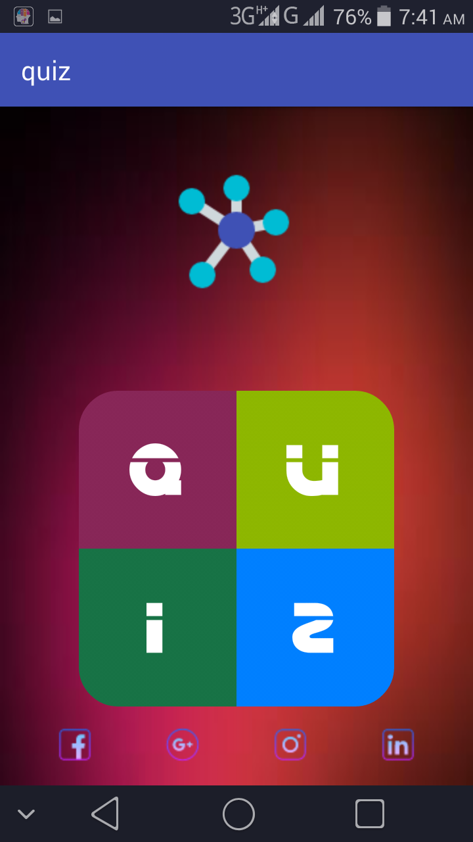

**Login.java**

**public class** MainActivity **extends** AppCompatActivity {  
 Button **signup**,**login**,**forg**,**face**,**goog**;  
 EditText **usernm**,**pass**;  
 @Override  
 **protected void** onCreate(Bundle savedInstanceState) {  
 **super**.onCreate(savedInstanceState);  
 setContentView(R.layout.***activity_main***);  
 **signup**=(Button)findViewById(R.id.***signup***);  
 **login**=(Button)findViewById(R.id.***login***);  
 **forg**=(Button)findViewById(R.id.***forgot***);  
 **usernm**=(EditText)findViewById(R.id.***username***);  
 **pass**=(EditText)findViewById(R.id.***pass***);  
 **face**=(Button)findViewById(R.id.***fb***);  
 **goog**=(Button)findViewById(R.id.***gp***);  
  
 **face**.setOnClickListener(**new** View.OnClickListener() {  
 @Override  
 **public void** onClick(View v) {  
 Toast.*makeText*(MainActivity.**this**, **"Service not yet available"**, Toast.***LENGTH_SHORT***).show();  
 }  
 });  
  
 **goog**.setOnClickListener(**new** View.OnClickListener() {  
 @Override  
 **public void** onClick(View v) {  
 Toast.*makeText*(MainActivity.**this**, **"Service not yet available"**, Toast.***LENGTH_SHORT***).show();  
 }  
 });  
 **forg**.setOnClickListener(**new** View.OnClickListener() {  
 @Override  
 **public void** onClick(View v) {  
 startActivity(**new** Intent(MainActivity.**this**,ForgotPassword.**class**));  
 finish();  
 }  
 });  
  
 **login**.setOnClickListener(**new** View.OnClickListener() {  
 @Override  
 **public void** onClick(View v) {  
 String user=**usernm**.getText().toString();  
 String pas=**pass**.getText().toString();  
 **if**(user.isEmpty() || pas.isEmpty())  
 {  
 Toast toast=Toast.*makeText*(MainActivity.**this**,**"Fill Username or Password"**,Toast.***LENGTH_LONG***);  
 toast.setGravity(Gravity.***TOP***,0,0);  
 toast.show();  
  
 }  
 **else** {  
 **try** {  
 String name = **null**;  
 String uid=**null**;  
 **int** t = 0;  
 Data f = **new** Data(MainActivity.**this**);  
 Cursor c = f.get();  
 **while** (c.moveToNext()) {  
  
 **if** (c.getString(3).equals(user) && c.getString(4).equals(pas)) {  
 t = 1;  
 name = c.getString(1) + **" "** + c.getString(2);  
 uid=c.getString(0);  
 **break**;  
 }  
  
 }  
 **if** (t == 1) {  
 **if** (user.equals(**"admin@admin.com"**) && pas.equals(**"123456789"**)) {  
 Intent intent = **new** Intent(MainActivity.**this**, Admin.**class**);  
 startActivity(intent);  
 finish();  
 } **else** {  
 Toast toast = Toast.*makeText*(MainActivity.**this**, **"Login Success"**, Toast.***LENGTH_LONG***);  
 toast.setGravity(Gravity.***TOP***, 0, 0);  
 toast.show();  
 Intent intent = **new** Intent(MainActivity.**this**, Quiz.**class**);  
 intent.putExtra(**"name"**, name);  
 intent.putExtra(**"uid"**,uid);  
 startActivity(intent);  
 finish();  
 }  
 } **else** {  
 Toast toast = Toast.*makeText*(MainActivity.**this**, **"Username or Password not found..."**, Toast.***LENGTH_LONG***);  
 toast.setGravity(Gravity.***TOP***, 0, 0);  
 toast.show();  
 }  
  
 }**catch**(Exception e){  
 Toast.*makeText*(MainActivity.**this**, **"error"**+e, Toast.***LENGTH_SHORT***).show();  
 }  
 }  
 }  
 });  
 **signup**.setOnClickListener(**new** View.OnClickListener() {  
 @Override  
 **public void** onClick(View v) {  
 startActivity(**new** Intent(MainActivity.**this**,Signup.**class**));  
 finish();  
 }  
 });  
 }  
  
 @Override  
 **public void** onBackPressed() {  
 AlertDialog.Builder alert=**new** AlertDialog.Builder(MainActivity.**this**);  
 alert.setMessage(**"Do you really want to Quit"**);  
 alert.setCancelable(**false**);  
 alert.setPositiveButton(**"YES"**, **new** DialogInterface.OnClickListener() {  
 @Override  
 **public void** onClick(DialogInterface dialog, **int** which) {  
 finish();  
 }  
 });  
 alert.setNegativeButton(**"NO"**, **new** DialogInterface.OnClickListener() {  
 @Override  
 **public void** onClick(DialogInterface dialog, **int** which) {  
  
 }  
 });  
 alert.create().show();  
 }  
 }

**login.xml**

*<?***xml version="1.0" encoding="utf-8"***?>*<**RelativeLayout xmlns:android="http://schemas.android.com/apk/res/android"  
 xmlns:tools="http://schemas.android.com/tools"  
 android:layout_width="match_parent"  
 android:layout_height="match_parent"  
 tools:context="com.example.hp.quiz.MainActivity"**>  
  
 <**ImageView  
 android:layout_width="fill_parent"  
 android:layout_height="fill_parent"  
 android:background="@drawable/image"**/>  
 <**ImageView  
 android:layout_width="match_parent"  
 android:layout_height="match_parent"  
 android:background="#50FFBF00"**/>  
 <**TextView  
 android:layout_marginTop="50dp"  
 android:gravity="center"  
 android:layout_width="match_parent"  
 android:layout_height="wrap_content"  
 android:text="Sign In"  
 android:textSize="40dp"  
 android:textColor="@android:color/white"  
 android:textStyle="bold"  
 android:background="#80DFFE90"  
 android:id="@+id/textView"** />  
  
 <**LinearLayout  
 android:layout_width="match_parent"  
 android:layout_height="wrap_content"  
 android:layout_marginTop="180dp"  
 android:orientation="vertical"  
 android:layout_marginLeft="30dp"  
 android:layout_marginRight="30dp"  
 android:id="@+id/linearLayout"**>  
  
 <**EditText  
 android:textColor="@android:color/white"  
 android:textSize="16dp"  
 android:layout_gravity="center"  
 android:layout_width="match_parent"  
 android:layout_height="wrap_content"  
 android:id="@+id/username"  
 android:hint="Enter Email"  
 android:textColorHint="@android:color/white"**/>  
  
 <**EditText  
 android:textColor="@android:color/white"  
 android:textSize="16dp"  
 android:layout_marginTop="40dp"  
 android:inputType="textPassword"  
 android:layout_gravity="center"  
 android:layout_width="match_parent"  
 android:layout_height="wrap_content"  
 android:id="@+id/pass"  
 android:hint="Enter Password"  
 android:textColorHint="@android:color/white"**/>  
  
 <**Button  
 android:layout_marginTop="40dp"  
 android:layout_gravity="center"  
 android:layout_width="150dp"  
 android:layout_height="wrap_content"  
 android:text="LOGIN"  
 android:id="@+id/login"  
 android:textSize="20dp"  
 android:textColor="@android:color/white"  
 android:background="@drawable/shape5"**/>  
 <**Button  
 android:id="@+id/signup"  
 android:textAllCaps="false"  
 android:layout_marginTop="20dp"  
 android:layout_width="match_parent"  
 android:layout_height="wrap_content"  
 android:text="No account yet? Create New"  
 android:background="#00FFFFFF"  
 android:textColor="@android:color/white"  
 android:textSize="16dp"**/>  
  
 <**TextView  
 android:layout_marginTop="1dp"  
 android:layout_gravity="center"  
 android:gravity="center"  
 android:layout_width="match_parent"  
 android:layout_height="wrap_content"  
 android:text="OR"  
 android:textSize="17dp"  
 android:textStyle="bold"  
 android:textColor="@android:color/white"** />  
 <**TextView  
 android:layout_width="match_parent"  
 android:layout_height="wrap_content"  
 android:layout_marginLeft="60dp"  
 android:textSize="16dp"  
 android:textColor="@android:color/white"  
 android:text=""**/>  
 </**LinearLayout**>  
  
 <**LinearLayout  
 android:layout_width="match_parent"  
 android:layout_height="wrap_content"  
 android:orientation="horizontal"  
 android:layout_marginTop="520dp"**>  
 <**Button  
 android:id="@+id/fb"  
 android:text="Facebook"  
 android:textColor="@android:color/white"  
 android:layout_marginLeft="10dp"  
 android:layout_weight="15"  
 android:background="#0047AB"  
 android:layout_width="150dp"  
 android:layout_height="50dp"  
 android:src="@drawable/fcb"**/>  
 <**Button  
 android:id="@+id/gp"  
 android:layout_marginRight="10dp"  
 android:text="Google +"  
 android:textColor="@android:color/white"  
 android:background="#D73B3E"  
 android:layout_marginLeft="15dp"  
 android:layout_weight="15"  
 android:layout_width="150dp"  
 android:layout_height="50dp"  
 android:src="@drawable/gp"**/>  
 </**LinearLayout**>  
<**LinearLayout  
 android:layout_width="match_parent"  
 android:layout_height="wrap_content"  
 android:layout_alignParentBottom="true"  
 android:layout_marginBottom="-10dp"**>  
 <**Button  
 android:id="@+id/forgot"  
 android:textAllCaps="false"  
 android:layout_width="match_parent"  
 android:layout_height="wrap_content"  
 android:layout_gravity="center"  
 android:text="Forgot Password?"  
 android:background="#00FFFFFF"  
 android:textColor="@android:color/white"  
 android:textSize="14dp"**/>  
</**LinearLayout**>  
</**RelativeLayout**>

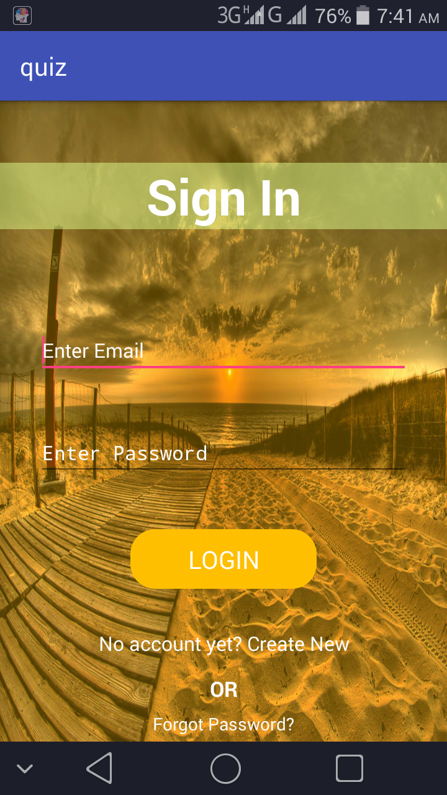

**Registration.java**

**public class** Signup **extends** AppCompatActivity {  
 EditText **password**,**cpassword**,**fname**,**lname**,**contact**,**email**;  
 ProgressBar **progress**;  
 Button **signup**;  
 Data **data**;  
 String **nm1**,**nm2**,**cont**,**pass**,**cpass**,**eml**;  
 @Override  
 **protected void** onCreate(Bundle savedInstanceState) {  
 **super**.onCreate(savedInstanceState);  
 setContentView(R.layout.***activity_signup***);  
  
 **password**=(EditText)findViewById(R.id.***password***);  
 **cpassword**=(EditText)findViewById(R.id.***cpassword***);  
 **progress**=(ProgressBar)findViewById(R.id.***passpro***);  
 **fname**=(EditText)findViewById(R.id.***fname***);  
 **lname**=(EditText)findViewById(R.id.***lname***);  
 **email**=(EditText)findViewById(R.id.***email***);  
 **contact**=(EditText)findViewById(R.id.***contact***);  
 **signup**=(Button)findViewById(R.id.***signup***);  
  
 **data**=**new** Data(**this**);  
 **signup**.setOnClickListener(**new** View.OnClickListener() {  
 @Override  
 **public void** onClick(View v) {  
 **nm1**=**fname**.getText().toString();  
 **nm2**=**lname**.getText().toString();  
 **eml**=**email**.getText().toString();  
 **pass**=**password**.getText().toString();  
 **cpass**=**cpassword**.getText().toString();  
 **cont**=**contact**.getText().toString();  
 **if**(**nm1**.isEmpty() || **nm2**.isEmpty() || **eml**.isEmpty() || **pass**.isEmpty() || **cpass**.isEmpty() || **cont**.isEmpty())  
 {  
 Toast toast=Toast.*makeText*(Signup.**this**,**"Please Fill All The Fields..."**,Toast.***LENGTH_LONG***);  
 toast.setGravity(Gravity.***TOP***,0,0);  
 toast.show();  
 }  
 **if**(!**pass**.matches(**cpass**))  
 {  
 Toast toast=Toast.*makeText*(Signup.**this**,**"Password doesn't match..."**,Toast.***LENGTH_LONG***);  
 toast.setGravity(Gravity.***TOP***,0,0);  
 toast.show();  
  
 }  
 **if**(**progress**.getProgress()!=100)  
 {  
  
 Toast toast=Toast.*makeText*(Signup.**this**,**"Password Strength isn't strong..."**,Toast.***LENGTH_LONG***);  
 toast.setGravity(Gravity.***TOP***,0,0);  
 toast.show();  
  
 }  
 **if**((!**eml**.contains(**"@"**))||(**eml**.startsWith(**"@"**))||(!**eml**.endsWith(**".com"**)))  
 {  
 Toast toast=Toast.*makeText*(Signup.**this**,**"Please enter valid email..."**,Toast.***LENGTH_LONG***);  
 toast.setGravity(Gravity.***TOP***,0,0);  
 toast.show();  
  
 }  
 **if**(**cont**.length()<10)  
 {  
 Toast toast=Toast.*makeText*(Signup.**this**,**"Enter valid contact..."**,Toast.***LENGTH_LONG***);  
 toast.setGravity(Gravity.***TOP***,0,0);  
 toast.show();  
  
 }  
 **else** {  
 **int** t=0;  
 Data f=**new** Data(Signup.**this**);  
 Cursor c= f.get();  
 **while** (c.moveToNext()){  
  
 **if**(c.getString(3).equals(**eml**))  
 {  
 t=1;  
 **break**;  
 }  
  
 }  
 **if**(t==1)  
 {  
 Toast toast=Toast.*makeText*(Signup.**this**,**"Email Already Exists"**,Toast.***LENGTH_LONG***);  
 toast.setGravity(Gravity.***TOP***,0,0);  
 toast.show();  
  
 }  
 **else** {  
 **int** t2=0;  
 **data**.add(**nm1**,**nm2**,**eml**,**pass**,**cont**);  
 Toast toast=Toast.*makeText*(Signup.**this**,**"Signup Successfull"**,Toast.***LENGTH_LONG***);  
 startActivity(**new** Intent(Signup.**this**,MainActivity.**class**));  
 toast.setGravity(Gravity.***TOP***,0,0);  
 toast.show();  
 **try** {  
 **data**.check_user_add(1);  
 Cursor c1 = **data**.check_abt_user();  
 **while** (c1.moveToNext()) {  
 t2++;  
 }  
 **if** (t2==1) {  
 **data**.insert_data();  
 **data**.insert_data_plus();  
 **data**.insert_data_java();  
 }  
 }**catch**(Exception e){  
 Toast.*makeText*(Signup.**this**, **""**+e, Toast.***LENGTH_SHORT***).show();  
 }  
 cln();  
 finish();  
 }  
  
  
 }  
 }  
 });  
  
 **progress**.getProgressDrawable().setColorFilter(  
 Color.***RED***, android.graphics.PorterDuff.Mode.***SRC_IN***);  
 **password**.addTextChangedListener(**new** TextWatcher() {  
 @Override  
 **public void** beforeTextChanged(CharSequence s, **int** start, **int** count, **int** after) {  
  
 }  
  
 @Override  
 **public void** onTextChanged(CharSequence s, **int** start, **int** before, **int** count) {  
 String text=**password**.getText().toString();  
  
 **if**(text.length()<2)  
 {  
 **progress**.setProgress(0);  
 **progress**.getProgressDrawable().setColorFilter(  
 Color.***RED***, android.graphics.PorterDuff.Mode.***SRC_IN***);  
 }  
 **else if**(text.length()<6)  
 {  
 **progress**.setProgress(40);  
 **progress**.getProgressDrawable().setColorFilter(  
 Color.***RED***, android.graphics.PorterDuff.Mode.***SRC_IN***);  
 }  
 **else if**(text.length()<8)  
 {  
 **progress**.setProgress(80);  
 **progress**.getProgressDrawable().setColorFilter(  
 Color.***YELLOW***, android.graphics.PorterDuff.Mode.***SRC_IN***);  
 }  
 **else** {  
 **progress**.setProgress(100);  
 **progress**.getProgressDrawable().setColorFilter(  
 Color.***GREEN***, android.graphics.PorterDuff.Mode.***SRC_IN***);  
 }  
 }  
  
 @Override  
 **public void** afterTextChanged(Editable s) {  
  
 }  
 });  
 }  
 **public void** cln(){  
 **fname**.setText(**null**);  
 **fname**.requestFocus();  
 **lname**.setText(**null**);  
 **email**.setText(**null**);  
 **password**.setText(**null**);  
 **cpassword**.setText(**null**);  
 **contact**.setText(**null**);  
 }  
  
 @Override  
 **public void** onBackPressed() {  
 startActivity(**new** Intent(Signup.**this**,MainActivity.**class**));  
 finish();  
 **super**.onBackPressed();  
 }  
}

**Registration.xml**

*<?***xml version="1.0" encoding="utf-8"***?>*<**RelativeLayout xmlns:android="http://schemas.android.com/apk/res/android"  
 xmlns:tools="http://schemas.android.com/tools"  
 android:layout_width="match_parent"  
 android:layout_height="match_parent"  
 tools:context="com.example.hp.quiz.MainActivity"**>  
  
 <**ImageView  
 android:layout_width="fill_parent"  
 android:layout_height="fill_parent"  
 android:background="@drawable/image"**/>  
 <**ImageView  
 android:layout_width="match_parent"  
 android:layout_height="match_parent"  
 android:background="#50FFBF00"**/>  
 <**TextView  
 android:layout_marginTop="50dp"  
 android:gravity="center"  
 android:layout_width="match_parent"  
 android:layout_height="wrap_content"  
 android:text="Create Account"  
 android:textSize="40dp"  
 android:textColor="@android:color/white"  
 android:textStyle="bold"  
 android:background="#80DFFE90"  
 android:id="@+id/textView"** />  
  
 <**LinearLayout  
 android:layout_width="match_parent"  
 android:layout_height="wrap_content"  
 android:layout_marginTop="180dp"  
 android:orientation="horizontal"  
 android:layout_marginLeft="30dp"  
 android:layout_marginRight="30dp"  
 android:id="@+id/linearLayout"**>  
  
 <**EditText  
 android:inputType="textCapWords"  
 android:layout_marginLeft="10dp"  
 android:layout_weight="20"  
 android:textColor="@android:color/white"  
 android:textSize="16dp"  
 android:layout_width="match_parent"  
 android:layout_height="wrap_content"  
 android:id="@+id/fname"  
 android:hint="First Name"  
 android:textColorHint="@android:color/white"**/>  
  
 <**EditText  
 android:inputType="textCapWords"  
 android:layout_marginLeft="10dp"  
 android:layout_weight="20"  
 android:textColor="@android:color/white"  
 android:textSize="16dp"  
 android:layout_width="match_parent"  
 android:layout_height="wrap_content"  
 android:id="@+id/lname"  
 android:hint="Last Name"  
 android:textColorHint="@android:color/white"**/>  
  
 </**LinearLayout**>  
  
 <**LinearLayout  
 android:layout_marginLeft="30dp"  
 android:layout_marginRight="30dp"  
 android:layout_width="match_parent"  
 android:layout_height="wrap_content"  
 android:orientation="vertical"  
 android:layout_marginTop="250dp"**>  
  
 <**EditText  
 android:layout_marginLeft="10dp"  
 android:layout_weight="30"  
 android:textColor="@android:color/white"  
 android:textSize="10dp"  
 android:inputType="textEmailAddress"  
 android:layout_width="match_parent"  
 android:layout_height="wrap_content"  
 android:id="@+id/email"  
 android:hint="Email"  
 android:textColorHint="@android:color/white"**/>  
  
 <**EditText  
 android:layout_marginTop="20dp"  
 android:layout_marginLeft="10dp"  
 android:layout_weight="30"  
 android:textColor="@android:color/white"  
 android:textSize="10dp"  
 android:inputType="textPassword"  
 android:layout_width="match_parent"  
 android:layout_height="wrap_content"  
 android:id="@+id/password"  
 android:hint="Password"  
 android:textColorHint="@android:color/white"**/>  
  
 <**EditText  
 android:layout_marginTop="20dp"  
 android:layout_marginLeft="10dp"  
 android:layout_weight="30"  
 android:textColor="@android:color/white"  
 android:textSize="10dp"  
 android:inputType="textPassword"  
 android:layout_width="match_parent"  
 android:layout_height="wrap_content"  
 android:id="@+id/cpassword"  
 android:hint="Confirm Password"  
 android:textColorHint="@android:color/white"**/>  
  
 <**EditText  
 android:layout_marginTop="20dp"  
 android:layout_marginLeft="10dp"  
 android:layout_weight="30"  
 android:textColor="@android:color/white"  
 android:textSize="11dp"  
 android:inputType="phone"  
 android:layout_width="match_parent"  
 android:layout_height="wrap_content"  
 android:id="@+id/contact"  
 android:hint="Contact Number"  
 android:textColorHint="@android:color/white"**/>  
  
 <**Button  
 android:layout_marginTop="40dp"  
 android:layout_gravity="center"  
 android:layout_width="180dp"  
 android:layout_height="38dp"  
 android:text="Signup"  
 android:id="@+id/signup"  
 android:textSize="20dp"  
 android:textColor="@android:color/white"  
 android:background="@drawable/shape5"**/>/>  
 </**LinearLayout**>  
 <**LinearLayout  
 android:layout_width="match_parent"  
 android:layout_height="wrap_content"  
 android:layout_alignParentTop="true"**>  
<**ProgressBar  
 android:layout_width="match_parent"  
 android:layout_height="wrap_content"  
 android:id="@+id/passpro"  
 style="@style/Widget.AppCompat.ProgressBar.Horizontal"  
 android:layout_gravity="center_horizontal"**/>  
 </**LinearLayout**>  
  
</**RelativeLayout**>

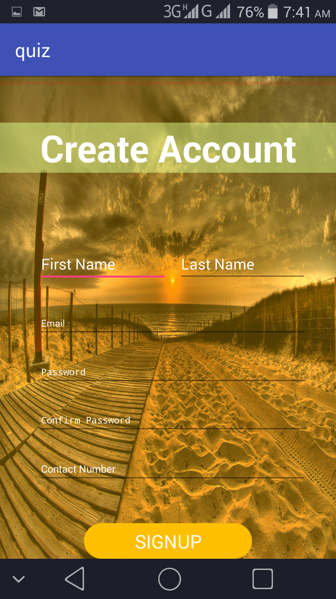

1. Sprint Backlog-2

**Quiz.java**

**package** com.example.hp.quiz;  
  
**import** android.app.AlertDialog;  
**import** android.content.DialogInterface;  
**import** android.content.Intent;  
**import** android.graphics.Typeface;  
**import** android.os.Bundle;  
**import** android.support.v7.app.AppCompatActivity;  
**import** android.support.v7.widget.PopupMenu;  
**import** android.view.MenuItem;  
**import** android.view.View;  
**import** android.widget.Button;  
**import** android.widget.ImageButton;  
  
**public class** Quiz **extends** AppCompatActivity {  
Button **select**,**name**,**c**,**plus**,**java**;  
 ImageButton **but**;  
String **value**=**null**,**uname**,**uid**;  
 @Override  
 **protected void** onCreate(Bundle savedInstanceState) {  
 **super**.onCreate(savedInstanceState);  
 setContentView(R.layout.***activity_quiz***);  
 **select**=(Button)findViewById(R.id.***selection***);  
 **name**=(Button)findViewById(R.id.***uname***);  
 **but**=(ImageButton)findViewById(R.id.***but***);  
 **c**=(Button)findViewById(R.id.***c***);  
 **plus**=(Button)findViewById(R.id.***plus***);  
 **java**=(Button)findViewById(R.id.***java***);  
  
 **uname**=getIntent().getStringExtra(**"name"**).toString();  
 Typeface tf = Typeface.*createFromAsset*(getApplicationContext().getAssets(),**"fonts/font2.ttf"**);  
 **select**.setTypeface(tf);  
 **name**.setText(**uname**);  
 **uid**=getIntent().getStringExtra(**"uid"**).toString();  
  
 **c**.setOnClickListener(**new** View.OnClickListener() {  
 @Override  
 **public void** onClick(View v) {  
 Intent intent=**new** Intent(Quiz.**this**,C.**class**);  
 intent.putExtra(**"nam"**,**uname**);  
 intent.putExtra(**"prog"**,**"C"**);  
 startActivity(intent);  
 }  
 });  
  
 **plus**.setOnClickListener(**new** View.OnClickListener() {  
 @Override  
 **public void** onClick(View v) {  
 Intent intent=**new** Intent(Quiz.**this**,C.**class**);  
 intent.putExtra(**"nam"**,**uname**);  
 intent.putExtra(**"prog"**,**"CPLUS"**);  
 startActivity(intent);  
 }  
 });  
  
 **java**.setOnClickListener(**new** View.OnClickListener() {  
 @Override  
 **public void** onClick(View v) {  
 Intent intent=**new** Intent(Quiz.**this**,C.**class**);  
 intent.putExtra(**"nam"**,**uname**);  
 intent.putExtra(**"prog"**,**"JAVA"**);  
 startActivity(intent);  
 }  
 });  
  
 **but**.setOnClickListener(**new** View.OnClickListener() {  
 @Override  
 **public void** onClick(View v) {  
 PopupMenu popup=**new** PopupMenu(Quiz.**this**,**but**);  
 popup.getMenuInflater().inflate(R.menu.***popup***,popup.getMenu());  
 popup.setOnMenuItemClickListener(**new** PopupMenu.OnMenuItemClickListener() {  
 @Override  
 **public boolean** onMenuItemClick(MenuItem item) {  
 **value**=item.getTitle().toString();  
 **if**(**value**.equals(**"Performance"**))  
 {  
 Intent intent=**new** Intent(Quiz.**this**,Performance_user.**class**);  
 intent.setFlags(intent.***FLAG_ACTIVITY_CLEAR_TOP***);  
 startActivity(intent);  
 finish();  
 }  
 **if**(**value**.equals(**"Logout"**))  
 {  
 Intent intent=**new** Intent(Quiz.**this**, MainActivity.**class**);  
 intent.setFlags(intent.***FLAG_ACTIVITY_CLEAR_TOP***);  
 startActivity(intent);  
 finish();  
 }  
 **if**(**value**.equals(**"Profile"**))  
 {  
 Intent intent=**new** Intent(Quiz.**this**,Profile.**class**);  
 *// Toast.makeText(Quiz.this, "1.) "+uid, Toast.LENGTH_SHORT).show();* intent.setFlags(intent.***FLAG_ACTIVITY_CLEAR_TOP***);  
 intent.putExtra(**"id"**,**uid**);  
 startActivity(intent);  
 }  
 **if**(**value**.equals(**"Setting"**))  
 {  
 Intent intent=**new** Intent(Quiz.**this**,Setting.**class**);  
 intent.putExtra(**"id"**,**uid**);  
 intent.setFlags(intent.***FLAG_ACTIVITY_CLEAR_TOP***);  
 startActivity(intent);  
 }  
 **return true**;  
 }  
 });  
 popup.show();  
 }  
 });  
 }  
  
 @Override  
 **public void** onBackPressed() {  
  
 AlertDialog.Builder alert=**new** AlertDialog.Builder(Quiz.**this**);  
 alert.setMessage(**"Do you really want to Logout"**);  
 alert.setCancelable(**false**);  
 alert.setPositiveButton(**"YES"**, **new** DialogInterface.OnClickListener() {  
 @Override  
 **public void** onClick(DialogInterface dialog, **int** which) {  
 Intent intent=**new** Intent(Quiz.**this**, MainActivity.**class**);  
 intent.setFlags(intent.***FLAG_ACTIVITY_CLEAR_TOP***);  
 startActivity(intent);  
 finish();  
 }  
 });  
 alert.setNegativeButton(**"NO"**, **new** DialogInterface.OnClickListener() {  
 @Override  
 **public void** onClick(DialogInterface dialog, **int** which) {  
  
 }  
 });  
 alert.create().show();  
 }  
  
  
}

**quiz.xml***<?***xml version="1.0" encoding="utf-8"***?>*<**RelativeLayout xmlns:android="http://schemas.android.com/apk/res/android"  
 xmlns:tools="http://schemas.android.com/tools"  
 android:layout_width="match_parent"  
 android:layout_height="match_parent"  
 tools:context="com.example.hp.quiz.MainActivity"**>  
  
 <**ImageView  
 android:layout_width="fill_parent"  
 android:layout_height="fill_parent"  
 android:background="@drawable/quiz1"**/>  
 <**ImageView  
 android:layout_width="match_parent"  
 android:layout_height="match_parent"  
 android:background="#60002E63"**/>  
 <**ImageView  
 android:layout_width="wrap_content"  
 android:layout_height="wrap_content"  
 android:src="@drawable/profile"** />  
 <**Button  
 android:id="@+id/uname"  
 android:layout_width="260dp"  
 android:layout_height="wrap_content"  
 android:layout_marginLeft="100dp"  
 android:layout_marginTop="25dp"  
 android:text=""  
 android:textAlignment="center"  
 android:textSize="20dp"  
 android:textStyle="bold"  
 android:textAllCaps="true"  
 android:textColor="@android:color/white"  
 android:background="@drawable/shape5"**/>  
  
<**ImageButton  
 android:id="@+id/but"  
 android:layout_width="150dp"  
 android:layout_height="70dp"  
 android:background="#30FFFFFF"  
 android:layout_marginLeft="220dp"  
 android:layout_marginTop="100dp"  
 android:src="@drawable/seat"**/>  
  
  
 <**LinearLayout  
 android:layout_width="match_parent"  
 android:layout_height="wrap_content"  
 android:orientation="vertical"  
 android:layout_marginTop="200dp"**>  
 <**Button  
 android:id="@+id/selection"  
 android:layout_width="match_parent"  
 android:layout_height="wrap_content"  
 android:text="Select Language"  
 android:background="#00FFFFFF"  
 android:textAlignment="center"  
 android:textSize="30dp"  
 android:textStyle="bold"  
 android:textColor="@android:color/white"** />  
 <**Button  
 android:layout_marginTop="30dp"  
 android:layout_width="match_parent"  
 android:layout_height="wrap_content"  
 android:text="C"  
 android:id="@+id/c"  
 android:textColor="@android:color/white"  
 android:textAlignment="center"  
 android:textSize="30dp"  
 android:background="@drawable/selection"**/>  
 <**Button  
 android:id="@+id/plus"  
 android:layout_marginTop="20dp"  
 android:textColor="@android:color/white"  
 android:textAlignment="center"  
 android:layout_width="match_parent"  
 android:layout_height="wrap_content"  
 android:text="C++"  
 android:textSize="30dp"  
 android:background="@drawable/selection"**/>  
 <**Button  
 android:id="@+id/java"  
 android:layout_marginTop="20dp"  
 android:textColor="@android:color/white"  
 android:textAlignment="center"  
 android:layout_width="match_parent"  
 android:layout_height="wrap_content"  
 android:text="JAVA"  
 android:textSize="30dp"  
 android:background="@drawable/selection"**/>  
</**LinearLayout**>  
 <**LinearLayout  
 android:layout_width="match_parent"  
 android:layout_height="wrap_content"  
 android:orientation="horizontal"  
 android:gravity="center"  
 android:weightSum="1"  
 android:layout_marginTop="480dp"**>  
  
 <**Button  
 android:id="@+id/text1"  
 android:layout_width="50dp"  
 android:layout_height="50dp"  
 android:text="Q"  
 android:textAlignment="center"  
 android:textStyle="bold"  
 android:textSize="20dp"  
 android:textColor="@android:color/white"  
 android:background="@drawable/shape4"** />  
 <**Button  
 android:id="@+id/text2"  
 android:layout_width="50dp"  
 android:layout_height="50dp"  
 android:text="U"  
 android:textAlignment="center"  
 android:textStyle="bold"  
 android:textSize="20dp"  
 android:textColor="@android:color/white"  
 android:background="@drawable/shape3"** />  
 </**LinearLayout**>  
  
 <**LinearLayout  
 android:layout_width="match_parent"  
 android:layout_height="wrap_content"  
 android:layout_marginTop="530dp"  
 android:orientation="horizontal"  
 android:gravity="center"  
 android:weightSum="1"**>  
  
 <**Button  
 android:id="@+id/text3"  
 android:layout_width="50dp"  
 android:layout_height="50dp"  
 android:text="I"  
 android:textAlignment="center"  
 android:textStyle="bold"  
 android:textSize="20dp"  
 android:textColor="@android:color/white"  
 android:background="@drawable/shape2"** />  
 <**Button  
 android:id="@+id/text4"  
 android:layout_width="50dp"  
 android:layout_height="50dp"  
 android:text="Z"  
 android:textAlignment="center"  
 android:textStyle="bold"  
 android:textSize="20dp"  
 android:textColor="@android:color/white"  
 android:background="@drawable/shape1"** />  
 </**LinearLayout**>  
  
</**RelativeLayout**>

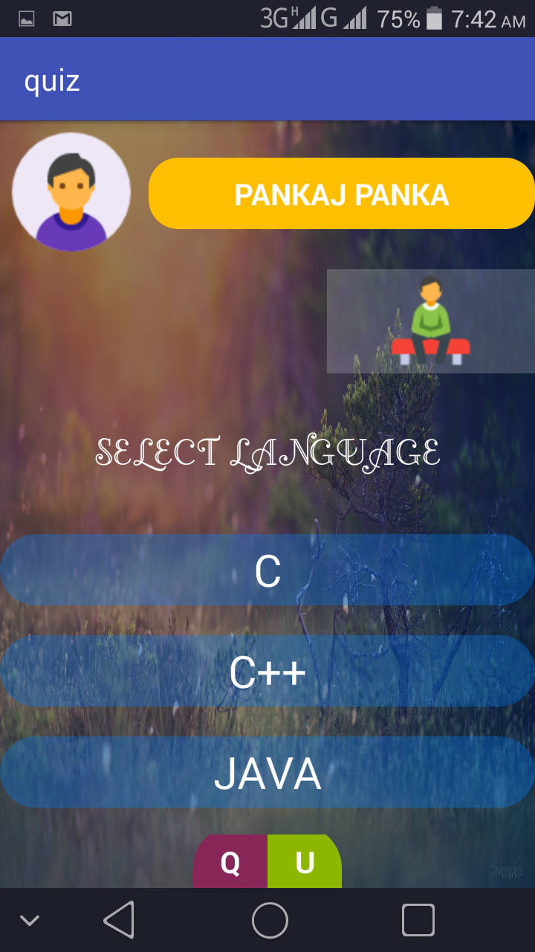

**Result.java**

**ackage** com.example.hp.quiz;  
  
**import** android.os.Bundle;  
**import** android.support.v7.app.AppCompatActivity;  
**import** android.widget.Button;  
**import** android.widget.TextView;  
  
**public class** Scorecard **extends** AppCompatActivity {  
 Button **nm**;  
 TextView **crct**, **atmp**, **grd**, **tot**;  
  
 @Override  
 **protected void** onCreate(Bundle savedInstanceState) {  
 **super**.onCreate(savedInstanceState);  
 setContentView(R.layout.***activity_scorecard***);  
 **nm** = (Button) findViewById(R.id.***name_user***);  
 **crct** = (TextView) findViewById(R.id.***corrct***);  
 **atmp** = (TextView) findViewById(R.id.***attempt***);  
 **grd** = (TextView) findViewById(R.id.***grade***);  
 **tot** = (TextView) findViewById(R.id.***ttl***);  
  
 String a = getIntent().getStringExtra(**"nme"**).toString();  
 String corct = getIntent().getStringExtra(**"correct"**).toString();  
 String attmp = getIntent().getStringExtra(**"attempt"**);  
 String totl = getIntent().getStringExtra(**"total"**).toString();  
  
 **tot**.setText(totl);  
 **nm**.setText(a);  
 **crct**.setText(corct);  
 **atmp**.setText(attmp);  
 Double p=Double.*valueOf*(corct);  
 Double qa=Double.*valueOf*(totl);  
  
 Double prec=(p / qa) * 100;  
  
 **grd**.setText(String.*valueOf*(prec)+**" %"**);  
 }  
  
}

**Result.xml**

*<?***xml version="1.0" encoding="utf-8"***?>*<**RelativeLayout xmlns:android="http://schemas.android.com/apk/res/android"  
 xmlns:tools="http://schemas.android.com/tools"  
 android:layout_width="match_parent"  
 android:layout_height="match_parent"  
 tools:context="com.example.hp.quiz.Scorecard"  
 android:background="@drawable/grass"**>  
  
 <**ImageView  
 android:layout_width="wrap_content"  
 android:layout_height="wrap_content"  
 android:src="@drawable/profile"**/>  
 <**Button  
 android:textSize="20dp"  
 android:id="@+id/name_user"  
 android:layout_width="260dp"  
 android:layout_height="wrap_content"  
 android:background="@drawable/selection"  
 android:layout_marginTop="20dp"  
 android:textStyle="bold"  
 android:textColor="#8DB600"  
 android:layout_marginLeft="100dp"  
 android:text="HELLO USER"**/>  
 <**ImageView  
 android:layout_marginTop="80dp"  
 android:layout_width="match_parent"  
 android:layout_height="wrap_content"  
 android:src="@drawable/cap"**/>  
 <**LinearLayout  
 android:layout_width="match_parent"  
 android:layout_height="wrap_content"  
 android:layout_marginTop="175dp"  
 android:background="@drawable/border"  
 android:layout_marginLeft="10dp"  
 android:layout_marginRight="10dp"  
 android:orientation="horizontal"**>  
  
 <**TextView  
 android:textAlignment="center"  
 android:layout_weight="10"  
 android:layout_width="match_parent"  
 android:layout_height="wrap_content"  
 android:text="Total Questions"  
 android:textStyle="bold"  
 android:textColor="@android:color/white"  
 android:textSize="25dp"**/>  
 <**TextView  
 android:id="@+id/ttl"  
 android:textAlignment="center"  
 android:layout_marginTop="20dp"  
 android:layout_weight="10"  
 android:layout_width="match_parent"  
 android:layout_height="wrap_content"  
 android:text="10"  
 android:textStyle="bold"  
 android:textColor="@android:color/white"  
 android:textSize="30dp"**/>  
  
 </**LinearLayout**>  
  
 <**LinearLayout  
 android:layout_width="match_parent"  
 android:layout_height="wrap_content"  
 android:layout_marginTop="260dp"  
 android:background="@drawable/border"  
 android:layout_marginLeft="10dp"  
 android:layout_marginRight="10dp"  
 android:orientation="horizontal"**>  
  
 <**TextView  
 android:textAlignment="center"  
 android:layout_weight="10"  
 android:layout_width="match_parent"  
 android:layout_height="wrap_content"  
 android:text="Attempt Questions"  
 android:textStyle="bold"  
 android:textColor="@android:color/white"  
 android:textSize="25dp"**/>  
 <**TextView  
 android:id="@+id/attempt"  
 android:textAlignment="center"  
 android:layout_marginTop="20dp"  
 android:layout_weight="10"  
 android:layout_width="match_parent"  
 android:layout_height="wrap_content"  
 android:text="10"  
 android:textStyle="bold"  
 android:textColor="@android:color/white"  
 android:textSize="25dp"**/>  
  
 </**LinearLayout**>  
 <**LinearLayout  
 android:layout_width="match_parent"  
 android:layout_height="wrap_content"  
 android:layout_marginTop="340dp"  
 android:background="@drawable/border"  
 android:layout_marginLeft="10dp"  
 android:layout_marginRight="10dp"  
 android:orientation="horizontal"**>  
  
 <**TextView  
 android:textAlignment="center"  
 android:layout_weight="10"  
 android:layout_width="match_parent"  
 android:layout_height="wrap_content"  
 android:text="Correct Questions"  
 android:textStyle="bold"  
 android:textColor="@android:color/white"  
 android:textSize="25dp"**/>  
 <**TextView  
 android:id="@+id/corrct"  
 android:textAlignment="center"  
 android:layout_marginTop="20dp"  
 android:layout_weight="10"  
 android:layout_width="match_parent"  
 android:layout_height="wrap_content"  
 android:text="10"  
 android:textStyle="bold"  
 android:textColor="@android:color/white"  
 android:textSize="30dp"**/>  
  
 </**LinearLayout**>  
  
 <**LinearLayout  
 android:layout_width="match_parent"  
 android:layout_height="wrap_content"  
 android:layout_marginTop="435dp"  
 android:background="@drawable/border"  
 android:layout_marginLeft="10dp"  
 android:layout_marginRight="10dp"  
 android:orientation="horizontal"**>  
  
 <**TextView  
 android:layout_width="match_parent"  
 android:layout_height="wrap_content"  
 android:layout_weight="10"  
 android:text="Total Percentage"  
 android:textAlignment="center"  
 android:textColor="@android:color/white"  
 android:textSize="25dp"  
 android:textStyle="bold"** />  
 <**TextView  
 android:id="@+id/grade"  
 android:textAlignment="center"  
 android:layout_marginTop="20dp"  
 android:layout_weight="10"  
 android:layout_width="match_parent"  
 android:layout_height="wrap_content"  
 android:text="10"  
 android:textStyle="bold"  
 android:textColor="@android:color/white"  
 android:textSize="30dp"**/>  
  
 </**LinearLayout**>  
  
</**RelativeLayout**>

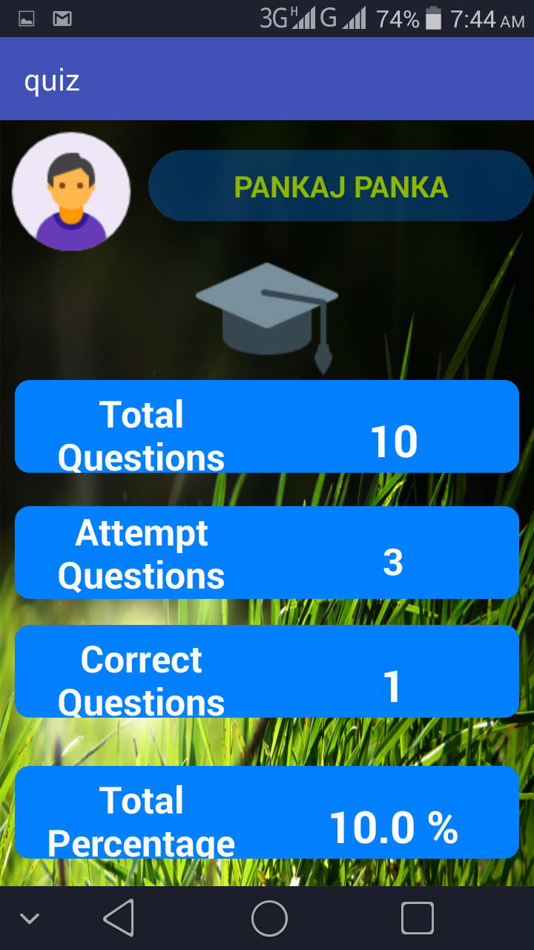

1. Sprint Backlog-3

( ***Project Design , Algo ,Database Design , ERD , Project Code ( Sample code only Limited to Max of 2-3 Page if needed , Project Screen Shots*** )

1. Sprint Backlog-4  
     
   ( ***Project Design , Algo ,Database Design , ERD , Project Code ( Sample code only Limited to Max of 2-3 Page if needed , Project Screen Shots*** )

**CHAPTER 5**

**CONCLUSION**

( 3 to 5 page)

Results

* 1. **SPLASH SCREEN**



* 1. LOGIN PAGE



* 1. REGISTRATION PAGE



* 1. FOGET PASSWORD

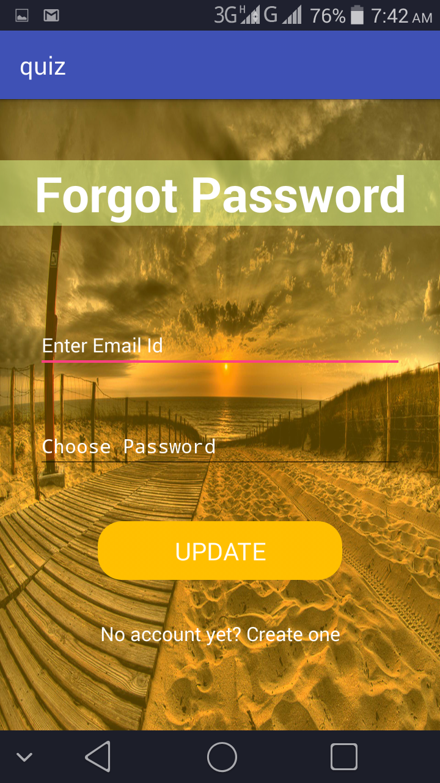 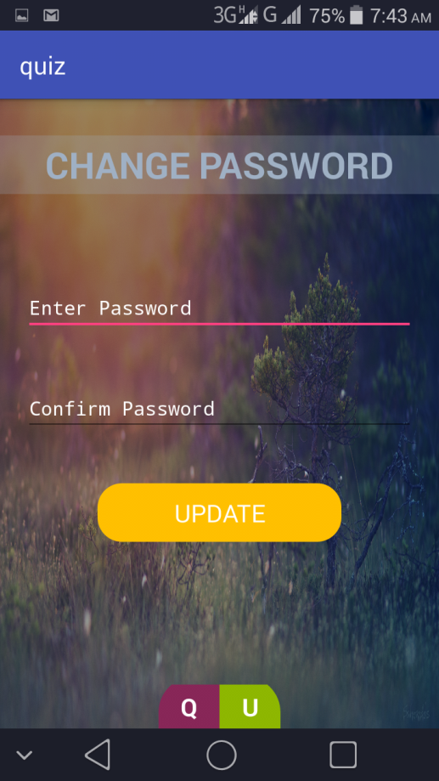

* 1. USER PROFILE

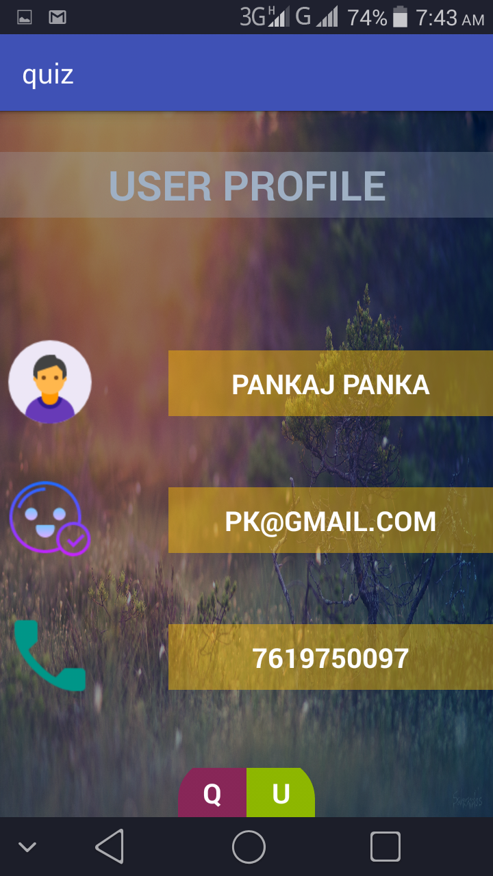 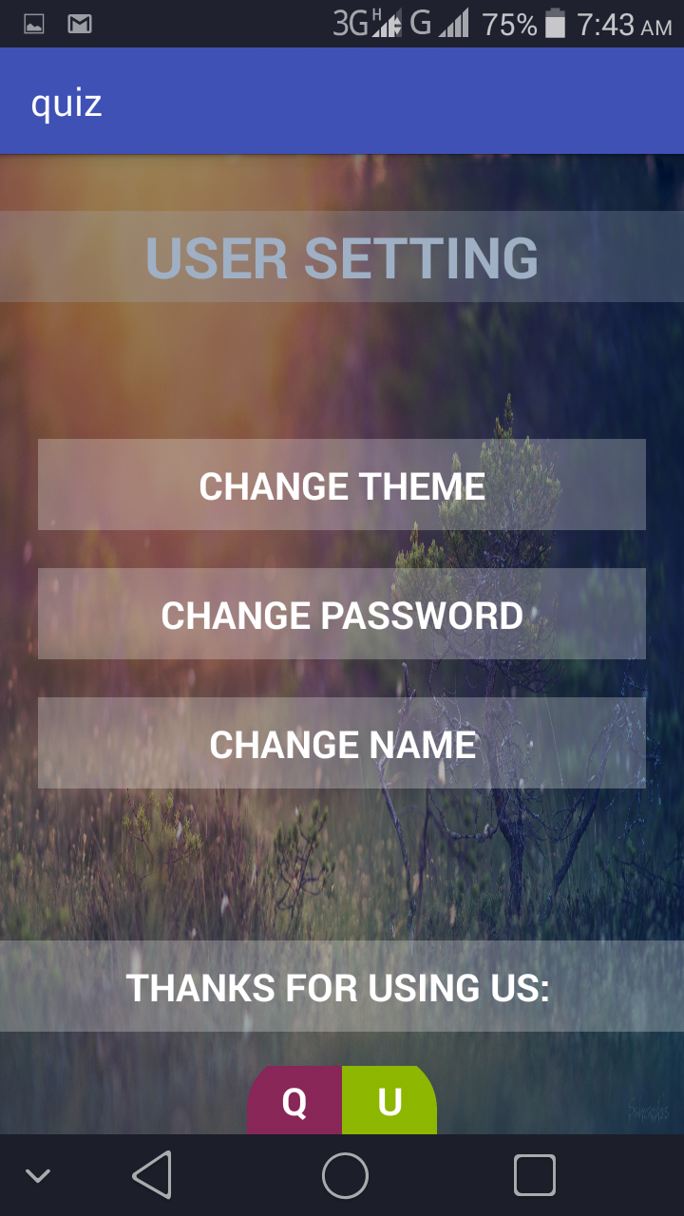

* 1. EXAM

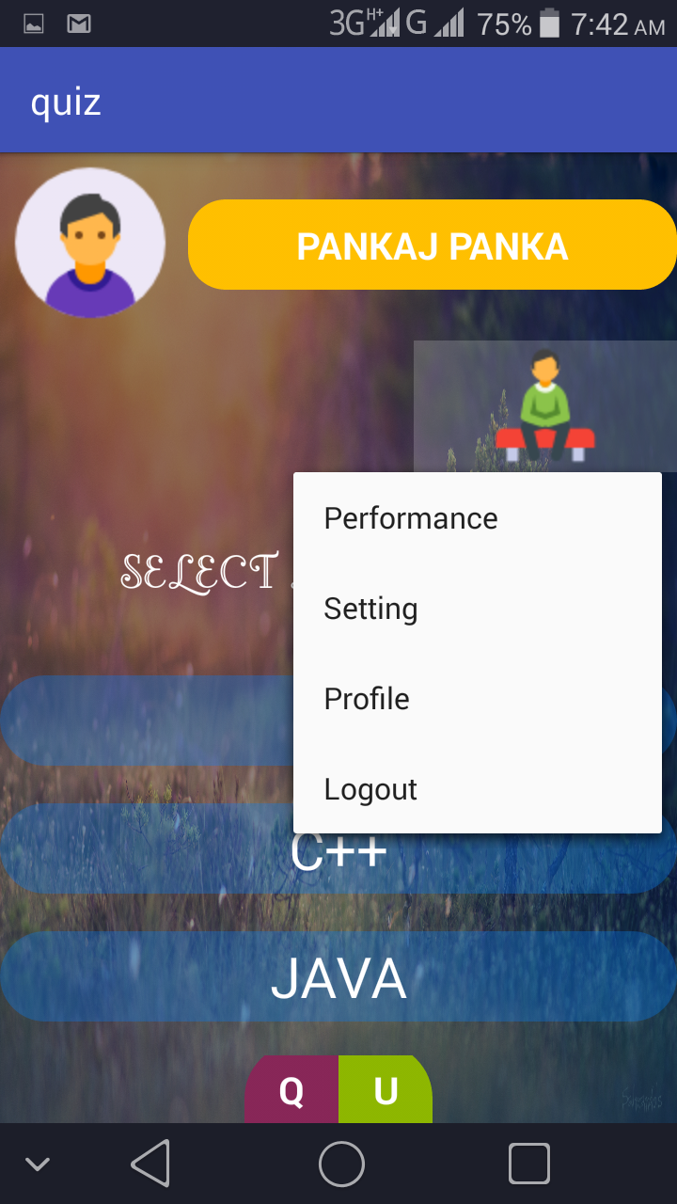 

* 1. QUESTION 8. RESULT

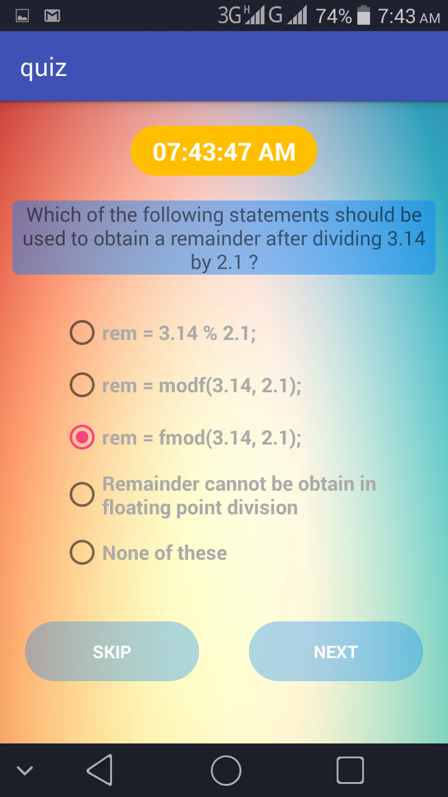 

**Outcome of online quiz**

Here are some Advantages of Online Quizzes. Taking online quizzes is becoming a huge success. But why is this such a huge success? What integrates people to use online quizzes instead of written quizzes? This article will tell you why this such a popular tool to use. And you may even want to do it yourself :)

**Advantages**

**Engage your audience**

Engage your audience in a unique and fun way and connect them to your brand or learning material. By creating a returning event, you will improve your consumer loyalty.

**Large number**

Taking online quizzes makes it possible to have a large number of participants. It could be up to a number of 1000 participants (and even more!). It doesn’t matter at what kind of location they take the online quiz as long as they are connected to the Internet.

**Randomizing questions**

It is significant more easy to randomize your question with just one click than to do it all manually. Randomizing questions and even answers of those questions is not a lot a of work to do with online quizzes. Besides the advantage of time saving, it also helps preventing students from [cheating](https://www.onlinequizcreator.com/knowledge-center/exam-knowledge-center/online-exam-cheating/item10616).

**Quiz results/ gain insight in audience**

Another plus of online quizzes is getting immediate results from your participants. Not only does the creator get the results, the participant itself is also possible to get his or her results. This makes it for the creator easy to identify the gaps in knowledge. The participants are able to view on what kind of section they have to improve themselves.

**More benefits of an online quiz**

**No instructor needed**

Quizzes can be given without an instructor, which saves money and time :)

**Set timer**

The creator is able to [set a timer](https://www.onlinequizcreator.com/features/online-test-maker-with-timer/item10236) for the whole quiz or to set a timer per question. This is possible to do with written quizzes, but is very time consuming for the instructor. Plus it’s almost impossible to do with a huge amount of participants.

**Better overview**

It’s possible to show one question at the time with online quizzes. People are not able to skip a question, because you will get a reminder that you can’t leave the answer blank.

**Improve your brand**

There are several ways to gain more brand awareness: Generate new interactive sales opportunities, build your traffic to your online channels, improve time spent on site and improve the sharing on social media about your campaign and brand.

**Conclusion:**

A large number of participants, with instant results of your online quiz (for the creator as well as the participants), a better overview, you’re able to randomize your questions and set a timer.That all without the need of an instructor. What’s holding you back to not use online quizzes?

**ANNEXURES**

References

[www.stackoverflow.com](http://www.w3schools.com/)

[www.w3schools.co m](http://www.w3schools.com/)

www.wikipedia.org

Research Paper ( if Presented and approved for publication)

DST Document presented for grants.

CV

**Instructions**

For Chapter Heading

Font: Times New Roman

Font Size: 14, Bold

Alignment: Center

Line Spacing 1.5

For Paragraph Heading

Font: Times New Roman

Font Size: 12, Bold

Alignment: Left

Line Spacing 1.5

For paragraph

Font: Times New Roman

Font Size: 12

Line Spacing 1.5

Alignment: Justify

Line Spacing 1.5